IMPLEMENTING SEVESO II IN THE NETHERLANDS – OPERATIONAL EXPERIENCES IN THE ROTTERDAM-RIJNMOND REGION

Jacques van Steen ¹, Tom Terstegge ² and Vivian Hoogstede ³

¹ DCMR Environmental Protection Agency, P.O. Box 843, 3100 AV Schiedam, Netherlands
(corresponding author)
² Labour Inspectorate, region Southwest, P.O. Box 9580, 3007 AN Rotterdam, Netherlands
³ Rotterdam Fire Brigade, P.O. Box 10062, 3004 AB Rotterdam, Netherlands

Abstract
Under the Dutch implementation of the 1982 Seveso Directive, reporting obligations for companies consisted of the submission of two reports: an External Safety Report and an Occupational Safety Report. In connection with other legislation, there was an additional reporting obligation associated with investigating the necessity of having a company fire brigade. These reports were evaluated separately by three different regulatory bodies.
For upper-tier establishments, the implementation of the Seveso II Directive in the Netherlands is characterized by the integration of the above-mentioned three reporting obligations into one report: the Safety Report. Evaluating a Safety Report will thus be a joint activity between the three regulatory bodies involved, and this will also be the case in carrying out the required inspections at upper-tier as well as lower-tier establishments. For the Rijnmond region, located in the vicinity of Rotterdam, these joint activities are an issue of major importance. Many chemical and petrochemical plants, power plants, and storage and transshipment companies are located in this area, and among these there are a substantial number of Seveso sites. As a consequence, organizing the required cooperation is a significant task in itself.
This paper discusses operational experiences between the key regulatory bodies in the Rotterdam-Rijnmond region: DCMR Environmental Protection Agency, region Southwest of the Labour Inspectorate, and Rotterdam Fire Brigade. Section 1 introduces the historical background from which the three bodies enter the required cooperation, by briefly describing the three pre-Seveso II reporting obligations. It also characterizes the Dutch implementation of Seveso II, and introduces the Rotterdam-Rijnmond region. Next, Section 2 deals with earlier joint experiences between the three bodies, which consisted mainly of carrying out inspections together on a voluntary basis and participating jointly in Seveso II pilot projects. Current activities between the three bodies are discussed in Section 3. These are concentrated around setting up an organisational structure for implementing Seveso II in the Rotterdam-Rijnmond region, and elaborating the necessary procedures. Section 4 presents some concluding remarks.

1. FROM SEVESO TO SEVESO II IN THE NETHERLANDS

The 1982 Seveso Directive was implemented in the Netherlands through a decree which was based on environmental, occupational safety, and disaster regulation. Under this decree, which was called BRZO (the Dutch acronym of Risks of Major Accidents Decree), one of the obligations for companies was the submission of two reports: an External Safety Report and an Occupational Safety Report. In connection with fire brigade regulation, there was an additional reporting obligation associated with investigating the necessity of having a company fire brigade. A schematic representation of Seveso implementation in the Netherlands is given in Figure 1.

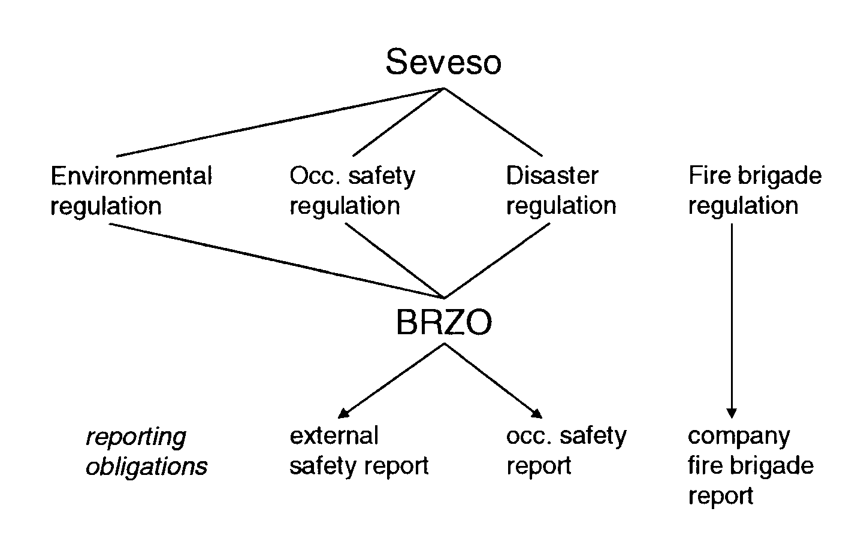

Figure 1. Implementation of 1982 Seveso Directive in the Netherlands

The above-mentioned three reports were evaluated separately by three different regulatory bodies:
• The External Safety Report, a public document, was evaluated by the Competent Authority for environmental regulation, which is either a province, a regional body, or a municipality. This evaluation, against nationally established criteria for individual and societal risk, was an office-based job which had to be completed within a prescribed period of time.
• The Occupational Safety Report, a confidential document, was evaluated by a region of the Labour Inspectorate, being the Competent Authority for occupational safety regulation. The evaluation included on-site inspections and was not limited by time constraints.
• The company fire brigade report was evaluated by the local or regional fire brigade, on behalf of the municipal authorities which are the Competent Authority for disaster and fire brigade regulation. The evaluation was focused on assessing the necessity of having a company fire brigade, from the perspective of fighting a representative accident scenario. Eventually, this necessity was the subject of discussion between fire brigade and company.

Seveso II
The Seveso II Directive is implemented in the Netherlands through a decree which is based on environmental, occupational safety, disaster, and fire brigade regulation. An important characteristic of this decree, which is called BRZO 1999, is cooperation between the key regulatory bodies, in particular the Competent Authority for environmental regulation, the Labour Inspectorate, and the fire brigade. Within this cooperation, the Competent Authority for environmental regulation serves as coordinator. Whereas cooperation as such is prescribed, the degree of cooperation is up to the various parties involved in a particular situation. This may vary from the competent authority for environmental regulation fulfilling a “mailbox function” (minimum situation) to operating jointly as a team (optimal situation). It is important to note here that the legal responsibilities of the various Competent Authorities remain unchanged.

As far as reporting obligations for upper-tier establishments are concerned, BRZO 1999 implies the integration of the three reports mentioned earlier into one report: the Safety Report. A schematic representation of Seveso II implementation in the Netherlands is given in Figure 2.

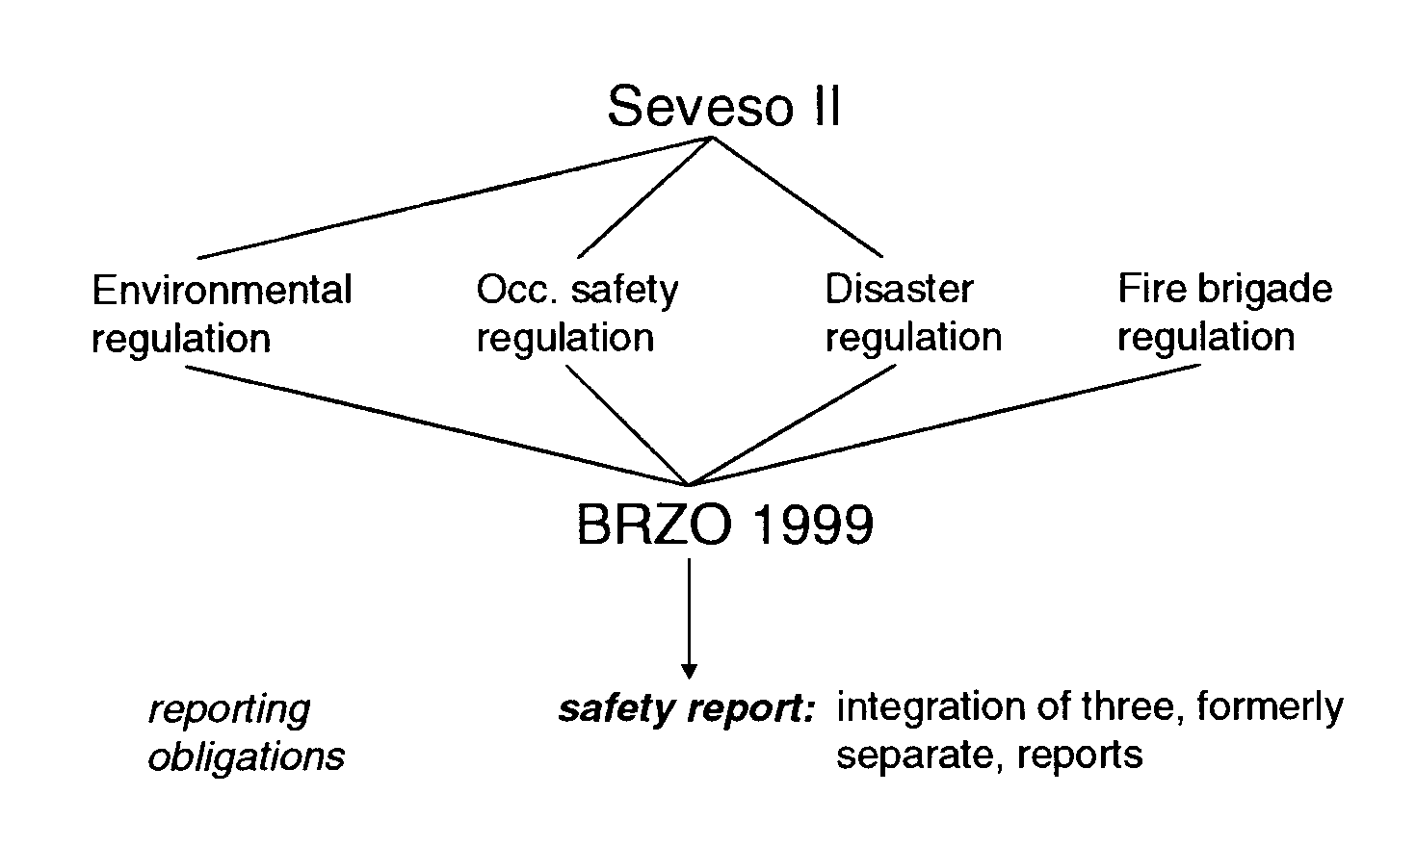

Figure 2. Seveso II implementation in the Netherlands

The integration of External Safety Report, Occupational Safety Report and company fire brigade report into one Safety Report affects the three regulatory bodies involved. These bodies are required to cooperate in evaluating the integrated Safety Reports, and cooperation is also required in carrying out the prescribed inspections at upper-tier as well as lower-tier establishments. For the Rijnmond region, located in the vicinity of Rotterdam, these joint activities are an issue of major importance. The Rotterdam-Rijnmond region is not only the most densely populated area in the Netherlands, with more than 1 million people living within an area of less than 800 km², but is also heavily industrialized. Many chemical and petrochemical plants, power plants, and storage and transshipment companies are located in this area, and among these there are a substantial number of Seveso sites. The estimated number of upper-tier establishments is about 55. The number of lower-tier establishments is less certain, but will be at least 50 and could also be much higher. Given these large numbers, organizing the required cooperation is a significant task in itself. In the Rotterdam-Rijnmond region, the starting-point for this process is favorable, since the three regulatory bodies involved have been cooperating successfully on a voluntary basis for a number of years. Some experiences with this voluntary cooperation between the bodies in question − DCMR Environmental Protection Agency, region Southwest of the Labour Inspectorate, and Rotterdam Fire Brigade − are described in the next section.

2. EARLIER JOINT EXPERIENCES BETWEEN THE THREE REGULATORY
BODIES IN THE ROTTERDAM-RIJNMOND REGION

The original obligation for the companies to prepare separate reports regarding external safety, occupational safety and fire brigade aspects implied a lot of duplication of information as well as multiple inspections by the three governmental bodies. Thus, it occurred very frequently that the separate governmental bodies were asked to combine their inspections and reports.

Accident investigations and occupational Safety Report inspections
Cooperation between Labour Inspectorate, DCMR and Rotterdam Fire Brigade had already taken place during major-accident investigations in the Rotterdam-Rijnmond area. In 1991, for example, an explosion of a storage tank occurred in which a flammable material was heated to above its flashpoint. A number of employees were killed and the environment was affected. Cooperation between the governmental bodies in investigating this accident clearly showed added value, and continuation of this practice appeared to be obvious. Since then, DCMR and Rotterdam Fire Brigade have been asked by the Labour Inspectorate to participate in teams for assessing the Occupational Safety Report and carrying out the associated inspections. Although this assessment is formally the task and competence of the Labour Inspectorate, it was very frequently experienced that audits and inspections resulted in a large number of shortcomings which were not only associated with occupational safety, but also with external safety, the environment, and emergency facilities. It was indeed experienced logical to discuss those shortcomings between company management and all governmental bodies in question together.

For a number of years, cooperation between Labour Inspectorate, DCMR and Rotterdam Fire Brigade continued. It must be emphasized that this cooperation was completely the inspectors' initiative − there were no rules or obligations issued by management. By operating jointly, the Labour Inspectorate, DCMR and Rotterdam Fire Brigade employees who participated in the inspections were able to get acquainted with each other's working methods, and everybody felt that this was a good opportunity to improve their overall inspection and audit techniques.

Parallel with the process of preparing the Seveso II Directive, an inspection method was developed for the Dutch government. This method, called AVRIM-2 [1], is considered a very appropriate inspection method by the Labour Inspectorate's inspectors, but it demands a very thorough and intensive training. The instrument itself is powerful, but rather complicated, and its application requires good auditing capabilities. It was therefore considered to be of paramount importance to start familiarizing with this instrument as early as possible. Thus, a number of projects have been carried out in which companies have been audited and inspected by a team from the three governmental bodies. The projects in question were mostly associated with assessing an Occupational Safety Report, and these assessments could be combined with training the project team members in applying AVRIM-2. In all cases, carrying out the inspection jointly and at the same time getting trained in applying AVRIM-2 was experienced as very successful, certainly by the government parties involved. Application of AVRIM-2 by only one inspector is difficult, and thus, AVRIM-2 inspections should preferably be carried out by teams. Especially here, cooperation appeared to be very fruitful.

The joint experiences discussed above also revealed aspects in which improvement is necessary. Enforcement is a typical example of this. Frequently, enforcement is possible by more than one governmental body, but it is not always clear beforehand which enforcement trajectory is most efficient. A second issue which has to be arranged in a clear way is the area of attention for the separate governmental bodies. An adequate division of tasks, in order to gain efficiency, is closely linked to this. It should be prevented that all parties involved pay detailed attention to all subjects.

Seveso II pilot projects
During the development of BRZO ’99, a number of pilot projects have been carried out in the Netherlands in order to support this development. One of the pilot projects in the Rotterdam-Rijnmond region was specifically focused on preparing an integrated Safety Report which would combine the External Safety Report, the Occupational Safety Report, and the company fire brigade report, and which would save time, workload and paperwork for industry. This project started early 1996, during the final stages of Seveso II development, as an industry initiative. Industry considered the forthcoming implementation of Seveso II in Dutch regulation as an opportunity to get their desire for an integrated Safety Report realized. More specifically, the purposes of this pilot project were to prepare a Safety Report in line with Seveso II and anticipated Dutch regulation, to identify any problems in preparing such a report, and certainly also to influence the Dutch Seveso II implementation.

The Safety Report in question was prepared for an Arco Chemical Company site which is located in the Rotterdam-Rijnmond region. The actual writing was done by a consultant, whereas a steering committee supervised the whole process. This committee consisted of representatives from industry and regional regulatory bodies, and the participation of DCMR, Labour Inspectorate, and Rotterdam Fire Brigade in the steering committee was in fact the first cooperation between these bodies in the context of Seveso II. The three ministries involved in the Dutch Seveso II implementation did not support the project. They considered it as an exclusive industry initiative which should not interfere with the development of the new legislation.

BRZO ’99 development started shortly after the beginning of the Arco pilot project. In 1997, as part of this development process, the Ministries in question initiated the preparation of a manual which would support particularly the companies in meeting the various information requirements associated with BRZO ’99, such as the notification, the major accident prevention policy, the Safety Management System, and the Safety Report. The three regulatory bodies participated in the committee which supervised the preparation of this so-called RIB document, where RIB stands for Report Information requirements BRZO ’99. Preparing the Safety Report for the Arco pilot project and preparing the RIB document profited mutually from each other. The Arco pilot project gained formal national Seveso II pilot project status in 1998, and the final version of the RIB document appeared in 1999 [2].

The Arco pilot project was evaluated in a separate project sponsored by the Dutch Ministry of Housing, Physical Planning and the Environment [3,4]. This evaluation was carried out before the formal completion of the pilot project in order to be able to use the findings in the revision process of the RIB document. As far as cooperation between the three Rotterdam-Rijnmond regulatory bodies was concerned, it was concluded that mutual understanding had grown and also that joint communication of these bodies with the company had been experienced as a positive aspect. For the regulatory bodies themselves, a number of issues appeared important for their future cooperation. Evaluating a Safety Report implies a statement about the acceptability of the risks, and the three bodies assess these risks from the point of view of their own legislation. As a consequence, this assessment takes place at different levels of detail − for example, the Labour Inspectorate needs more detailed information for their evaluation process than the other two bodies. It is considered crucial for successful cooperation that all who are involved in the Safety Report evaluation are aware of these differences in perspective. Other issues of importance are concerned with workload and training. BRZO ’99 involves new tasks in comparison with its predecessor − carrying out inspections is a new task for DCMR and Rotterdam Fire Brigade, for example. These new tasks will require additional manpower for all three regulatory bodies, and they also make that training new as well as existing employees will be an important issue in the actual implementation of BRZO ’99.

3. BRZO ’99 IMPLEMENTATION IN THE ROTTERDAM-RIJNMOND REGION

Parallel with the Seveso II pilot projects, and in addition to the fairly good cooperation between the three regulatory bodies which was generated over the years, a formal organisational structure was set up to prepare the implementation of BRZO ’99 in the Rotterdam-Rijnmond region and to supervise the actual execution of the required activities, at the managerial as well as the operational level (see Figure 3). Such a formal structure was considered necessary in view of the magnitude of the operation.

Steering
Committee
Coordinating
Committee
working groups |  |  |  | project groups

Figure 3. Organizational structure for BRZO ’99 imple-

mentation in the Rotterdam-Rijnmond region

At the operational level, a coordinating committee was established which meets at regular intervals (about once every six weeks). Two kinds of groups operate under supervision of this committee: working groups and project groups. The working groups address generic issues associated with implementing BRZO ’99. Working groups have been set up for the following issues:
• notification aspects;
• setting up an inspection program (“planning”);
• an agreed division of tasks;
• the approach to carrying out inspections;
• the approach to assessing lower-tier establishments;
• standardized formats for letters and reporting;
• the enforcement of violations of law; and
• internal as well as external communication.

The documented results of the working groups will form the starting-point for developing a Rotterdam-Rijnmond BRZO ’99 manual. This manual will be focused on operational procedures and also contain all kinds of relevant background information, such as data on available inspection methods. One of its key objectives will be to enhance consistency throughout all activities required by BRZO ’99.

The project groups are the teams which are involved with evaluating the notification and the Safety Report, and with carrying out the inspection. Thus, the project groups are concerned with the actual implementation of BRZO ’99. For each project (= company), a project group is installed representing the three regulatory bodies.

At the managerial level, a steering committee was established which consists of the directors of the three bodies. This committee will meet less frequently than the coordinating committee, say twice a year. It will have supervisory responsibilities, and be concerned, for example, with ratifying the division of tasks and deciding about such problems as manpower limitations.

In addition to setting up the organisational structure for implementing BRZO ’99, current activities include organising the necessary manpower and training all parties involved, which were already mentioned in subsection 2.2 as important issues. BRZO ’99 implies new tasks for all three bodies, and, as a consequence, currently available manpower will not be sufficient to fulfill all existing and new obligations. It appeared from the Arco pilot project that a full evaluation of the risks of an upper-tier establishment, which means evaluating the Safety Report, carrying out an inspection, and writing the joint evaluation report, may involve between 25 and 50 man-days. This information was used to estimate the additional manpower needed, and all three bodies have received financial resources from their respective ministries in order to supplement the currently available manpower. These extra resources will cover the new obligations in the long term, but there may remain short-term problems. All Safety Reports have to be submitted by 3 February 2001 at the latest, and each Safety Report evaluation has to be completed within six months, with a possible extension of three months. Thus, there will be a workload peak until the end of the year 2001, and the available manpower may be insufficient to cover this peak.

Training all parties involved is also an issue of key importance. Currently, an introductory course is organized nation-wide by the three Ministries involved. In addition, the three regulatory bodies themselves will organize regional training activities, for example in auditing and inspection methods. Objectives with this regional training are to create comparable knowledge levels between the three bodies and to ensure that the various project groups apply the same approach to assessing the Safety Management System, the risk analysis, and other technical aspects of the installation in question. And finally, there will be “on-the-job training” within the various projects.

4. CONCLUSIONS AND PERSPECTIVE

The successful execution of BRZO ’99 represents a substantial, but challenging task. BRZO ’99 requires cooperation between regulatory bodies, and this is new in comparison with BRZO, the Dutch implementation of the 1982 Seveso Directive. The various bodies in the Rotterdam-Rijnmond region have been cooperating successfully on a voluntary basis for a number of years. Thus, the starting-point for the future is sound, although it is realised that cultural differences between the three bodies, and the impact of these differences on cooperation, should not be underestimated and must receive adequate attention. Furthermore, the large number of Seveso establishments in the Rotterdam-Rijnmond region requires a formal organisational structure for BRZO ’99 implementation as well as a documented approach to the various issues. This approach will be laid down in the Rotterdam-Rijnmond BRZO ’99 manual, the first version of which will appear in the beginning of 2000. The manual will be further refined on the basis of actual experiences with evaluating Safety Reports and carrying out inspections.

ACKNOWLEDGMENT

The authors wish to acknowledge the contribution of the many individuals within DCMR, Labour Inspectorate, and Rotterdam Fire Brigade who have been and are involved in organizing as well as actually implementing the cooperation between these three bodies.

REFERENCES

[1] L.J. Bellamy and J. van der Schaaf, Major hazard management: Technical-management links and the AVRIM-2 method. Proceedings of the Seveso 2000 European Conference on Risk management in the European Union of 2000: The challenge of implementing Council Directive ‘Seveso II’ (Athens, Greece, November 1999).
[2] Report information requirements BRZO ’99. Committee for the Prevention of Disasters, report CPR 20, Sdu Uitgevers, Den Haag, Netherlands, 1999. (in Dutch; English version to appear in 2000)
[3] J.M. Ham, Safety Report pilot project Seveso-II for Arco Chemie Nederland Ltd. − Description of lessons learnt. TNO-MEP Report R 98/083, TNO Environment, Energy and Process Innovation, Apeldoorn, Netherlands, April 1998. (in Dutch)
[4] J.M. Ham, J.C.M. van Kessel and T. Wiersma, Experiences with a Safety Report according to Seveso-II: A pilot project in the Netherlands. Proceedings of the 9th International Symposium on Loss Prevention and Safety Promotion in the Process Industries (Barcelona, Spain, May 1998).

