Lessons for Seveso II from Longford Australia

G. D. Kenney, M. Boult, R. M. Pitblado,

DNV, 3 Palace House, Cathedral St, London SE1 9DE

Abstract
On Friday, 25 September 1998, at about 12.26 in the afternoon, a vessel in the Esso Longford Gas Plant fractured releasing hydrocarbon vapours and liquid. Explosions and a fire followed. Two Esso employees were killed and eight others were injured. Supplies of natural gas to domestic and industrial users were halted for between 9-19 days. The State of Victoria, which is highly dependent on natural gas, suffered substantial disruption to the economy. The Government ordered a Royal Commission to investigate the causes of the incident and it published its final report recently (Govt Victoria, 1999). DNV acted as technical adviser.

The main lessons to be drawn from Longford relevant to Seveso II are, in the opinion of the authors, as follows:
- Safety Management System – incomplete implementation
- Knowledge Stewardship – insufficient on old plant
- Management of Change – organisational change not subjected to this procedure
- Audit and Review – opportunities to discover gaps were missed

- INTRODUCTION

This paper will present some key features of the accident, as determined by the Royal Commission, and comment on possible implications for those implementing Seveso II safety cases in Europe.

DNV’s role was to act as technical adviser to the Royal Commission throughout its investigation, and therefore is in a position to offer some insights. The authors regard it is as a serious professional duty to ensure that key findings are shared with others responsible for process plants in a timely manner. However, litigation will follow and DNV is careful where relevant only to quote from the public record of the Royal Commission. This is made clear in this paper by the use of italic typeface for direct quotations.

Finally, in any inquiry there tends to be a focus in black & white terms on those things that were wrong or deficient, however there is much that was right with the Esso facility, and perhaps shades of grey on others. The most powerful lesson from Longford, in the author’s opinion, is that a well-run facility, with a world-class safety management system can still experience a major event. This paper will outline how omissions or deficiencies could overcome the other safeguards in place.

BACKGROUND TO THE EVENT

2.1 The Process
At Longford, Esso Australia operates three gas plants to process gas flowing from wells in the Bass Strait. It also operates a Crude Oil Stabilisation Plant (CSP) to process oil flowing from other wells in the Bass Strait. The gas plants are known as Gas Plant 1 (GP1), Gas Plant 2 (GP2) and Gas Plant 3 (GP3). They are numbered in the order in which they were built, starting with GP1, which commenced production in March 1969.

A simplified overview of the GP1 Unit is given in block diagram form in Figure 1. The event occurred within the Circulating Oil System.

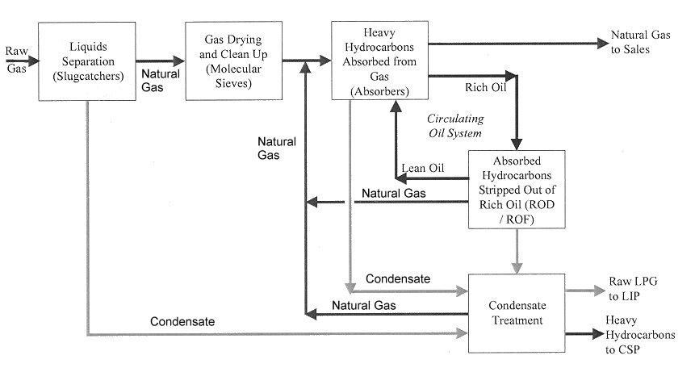

Figure 1. Overview of GP1 Unit

The process flow diagram (Figure 2) shows only the oil circulation for clarity, not the gas and condensate streams. In broad terms, the process passes chilled natural gas containing condensate (ethane, propane and butane) into the Absorber vessels and in counter-current flow absorbs the condensate in Lean Oil at a temperature of about –20°C. The saturated Lean Oil leaving the Absorbers is termed Rich Oil.

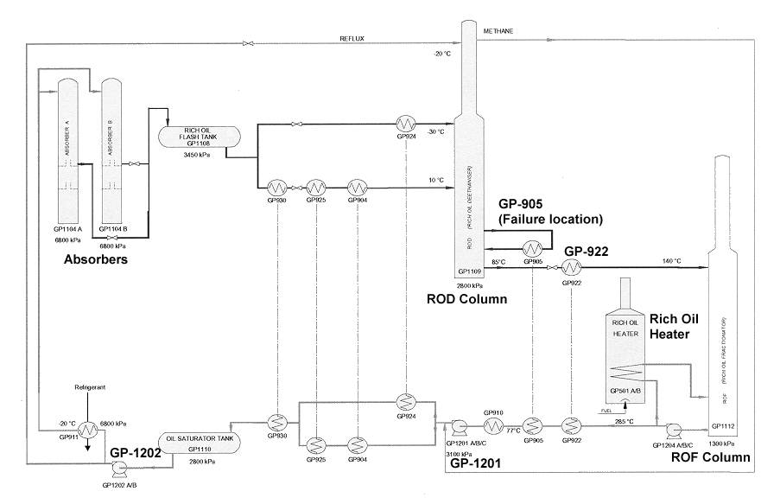

Figure 2. Process Flow Diagram of Absorber Oil Recirculation Loop

Rich Oil is passed after flashing (Rich Oil Flash Tank) and heat exchange to the ROD (Rich Oil De-ethaniser). This is a fractionation tower where ethane is removed at the top and heavier components collect in the bottom and are recirculated by means of a reboiler, GP-905, the item that failed in this incident. The bottoms Rich Oil stream passes through another heat exchanger, GP-922 (that was leaking on the day of the incident), to the ROF (Rich Oil Fractionator) where final fractionation of the Rich Oil occurs, regenerating the Lean Oil in the bottoms. This Lean Oil is passed to fired heaters and then through a series of other exchangers providing heat energy to the process, before returning to the Absorber in a closed loop.

There were a number of precursors to the leak event at GP-905. The actual sequence of events, the high degree of interconnections and interactions, means that post-event analysis is difficult, underlining the diagnosis problem which must have been faced by the operators.

There was a high liquids content in the feed to the slug-catchers before the plant. The level of condensate in Absorber B rose to a point where it was not possible to measure it by the available instrumentation. In all probability, the level of condensate in Absorber B was such that it carried up into the rich oil section of the absorber. That meant that condensate entered the rich oil stream causing that stream to flash more than usual on its way to the Rich Oil Flash Tank, GP1108, and to drop in temperature.

A consequence of the rise in the level of the Oil Saturator Tank was that LRC2 closed the valve regulating the flow from the GP1201 pumps. This reduction in flow would have caused LFSD8 to shut down the GP1201 pumps.

Lean oil circulation stopped when the GP1202 pump shut down.

Within five minutes of loss of lean oil circulation, the flow would have ceased to be a mixture of rich oil and condensate and would have become pure condensate.

Following the cessation of lean oil flow, the condensate flowing from the absorbers through the rich oil system was flashing at lower and lower temperatures with the result that there was a drop in temperature in the Rich Oil Flash Tank and the ROD system.

Simulations indicate that the temperature reached as low as -48°C in this section of the plant.

Both GP905 and GP922 exhibited signs of extreme coldness by the formation of ice on the uninsulated parts of their exteriors and on the pipework to and from them. A decision was made to shut down GP1 shortly after 11.00 am.

One of the vessels involved was GP905. The reduction in temperature of that vessel caused the embrittlement of its steel shell. When hot lean oil was re-introduced into the vessel it ruptured by way of brittle fracture at its eastern end, releasing a volume of hydrocarbon vapour which travelled towards the area of the fired heaters where it ignited, causing an explosion and fire.

2.2 Organisational Background
The situation described above took place in an organisational context which is useful to outline. The site, like most others in the process industry, had been the subject of several manpower reviews over the years to maintain its efficiency and competitiveness.

The Commission noted that… One feature of Esso’s management structure was its depth of engineering expertise and operational experience.

The Commission highlighted….Two structural changes to operations management occurred at Longford, which were relevant to the matters under investigation. These changes were the relocation of engineers from Longford to Melbourne and the redefinition of the role and responsibilities of supervisors and operators.

The effect of shifting engineers to Melbourne was to lessen, in the Commission’s view, the ready availability of specialist engineering knowledge (e.g. materials and process) on the site, as opposed to operations knowledge, which remained local. Esso anticipated these changes and made alternative arrangements to ensure engineering knowledge accessibility. Engineers typically undertook both a “surveillance” role and a “project” role. To assist with the former, Esso introduced a process data transmitting system (PIDAS) that allowed Melbourne-based engineers real-time access to process variables. The Company also retained a corporate airplane to make travel to the site easier.

The other matter, the reorganisation of supervisors meant that …
the primary role of the shift supervisors had become largely administrative, since, by agreement with the four unions represented at Longford, the responsibility for effective plant operation had been transferred to the operators.

A further organisational change occurred in mid-1996, pursuant to an enterprise bargaining agreement. The number of operating areas at the Longford plants was reduced from 14 to 12 and the offshore control room was consolidated into the GP3 control panel position.
Maintenance staffing was also reviewed and reduced…. Following these changes the number of supervisors and associated staff at the Longford plant fell from 25 in 1993 to 17 in 1998. Over the same period, there was also a reduction in the number of maintenance staff from 67 to 58.

Whilst criticism has been directed at Esso’s reduction of its maintenance staff at Longford and its allocation of priority to work order requests, the Commission finds that Esso’s standards, practices and procedures with regard to theses matters did not cause or contribute to the occurrence of the explosion, fire or failure of gas supply.

2.3 Staffing and Equipment Issues
No real plant operates all the time with its entire staff present and all its equipment functioning perfectly. Systems are designed to have replacement staff available and / or technical solutions for malfunctioning equipment. Some relevant personnel substitutions or breakdowns on the day included:
- on the day of the accident, the plant manager was at Long Island Point participating in a work safety presentation.
- the position of Operations Superintendent was vacant, and the person acting as Operations Superintendent was on holiday.
- the person substituting for the Acting Superintendent was away ill
- the Commission identified 4 other staff involved in the incident who were relieving or acting for others
- the day crew for the shift were all on training at the time when extra manpower was requested

A distraction for the available operations staff was a leakage from GP-922 heater near to GP-905. This also was showing external ice build-up and staff were attempted to stop the leakage of oil. … the decision was made to re-introduce lean oil flow into GP922 to try and stop the leak.

An equipment issue of importance relates to TRC3B, the condensate reboiler controller on Absorber B column…The TRC3B valve had been giving trouble for some time before the accident on 25 September. This had the effect that control of the bottom temperature was poor. Ultimately condensate rose up into the Rich Oil part of the column and was transported with it to the ROD area.

2.4 The Metallurgy of the Failure
A catastrophic end failure occurred to exchanger GP-905. Essentially the whole end was ripped open and the contents of the exchanger, the ROD column, and all its interconnections were rapidly released. Metallurgical analysis showed: The featured surface and ligaments indicate that the crack propagated slowly while it was in the weld. …. It is concluded that the failure in the channel was fast brittle fracture.

Toughness tests confirmed the material failed in a fully brittle manner at –50°C and predominantly brittle at –30°C.

With the defects of the size found at the 8 o’clock position, GP905 would not have failed if its internal pressure was the same as that of the ROD and the metal temperatures were at -48°C. From this it was concluded that another source of stress was required. There was no evidence of any external impact. For this reason, there must have been thermally induced stresses. A temperature difference of the order of 20°C would have been sufficient to result in the failure on 25 September 1998.

THE EVENT

From an engineering assessment made of the volumes and mass of the various flammable hydrocarbons that were contained within GP1 at the time GP905 ruptured, it appears that somewhere between 20,000 and 25,000 kilograms (20-25 tonnes) of sales gas, ethane, condensate, and lean and rich oil were liable to escape from the rupture of GP905.

The south-south easterly drift of the vapour cloud from the ROD/ROF area was towards the general direction of the gas-fired heaters, located approximately 170 metres away at the southern boundary of the plant. It would have taken in the order of 30-60 seconds for the cloud to drift this distance.

The development of the cloud was modelled using a computer simulation code. This modelling demonstrated that the front edge of the cloud would have contained a sufficient mixture of flammable hydrocarbons and air for it to ignite once it found a suitable ignition source. The burn pattern of the cloud, the eyewitness descriptions of the movement of the flame front and the lack of any significant overpressure damage, all support the conclusion that the front edge of the cloud ignited once it reached the fired heaters. It is probable that the cloud was ignited by the hot oil heater AX501 or the regeneration gas heaters AX502A and AX502B, all of which were still being fired.

The combined Esso, Country Fire Authority, Police emergency response was judged to be good. Some security gate delays were encountered in the first few minutes, but other than this the team worked well. In evidence some of the Esso operators responses were termed “heroic”.

The initial vapour cloud was ignited and the effect was termed explosion in the press and evidence. The Commission was more explicit: When it reached the exchanger the cloud erupted into an ‘angry red orange ball of fire’. While the term ‘explosion’ has been used to characterise the ignition of the initial vapour cloud, the appropriate technical term to describe this ignition is a ‘flash fire’ or ‘deflagration’.
A fuller modelling analysis of the vapour cloud event and subsequent fires is given in the Commission Report (Govt Victoria, 1999) and by Spouge and Pitblado (in press). After the initial release at 12:26 and vapour cloud fire that caused the deaths and injuries, the flame front travelled back to the source and a prolonged fire ensued in this area. Unfortunately, this was beneath a critical pipe-rack junction called “King’s Cross”. The flames impinging on this pipe rack led to three other rapid releases of large flammable inventories over a 30 minute period, from 13:00 to 13:32. These were also termed explosions in the reporting, but more accurately were similar to BLEVE events from large pipes rather than pressure vessels.

A major problem for the Esso operating staff was to isolate the many pipes passing through this critical junction of pipe racks. The GP-905 exchanger was 5-10m from this junction (see Figure 3). The total isolation of the pipes feeding the fire required nearly 2½ days. This was due to major interconnections between the 3 gas plants. The Commission reported… Geoff Evans, a [Country Fire Authority] operations manager, was concerned about the ad hoc nature of the isolation of fuel sources. At 2.30 pm on Saturday, 26 September, he had a discussion with Mick Brack, an Esso acting operations superintendent. He asked Brack for a detailed plan of the plant’s pipework to assist the IMT in identifying which valves should be isolated to stop the flow of fuel to the fires. Brack said that he did not have a plan available and that in any event, the Longford plant was a hybrid, having had its original design modified on a number of occasions, so that a plan, even if one could be located, might not have been of much assistance.

The interconnections between the processing units at Longford together with the policy of providing built-in spare equipment has proved successful in maintaining a secure supply of sales gas for Victoria for almost 30 years.

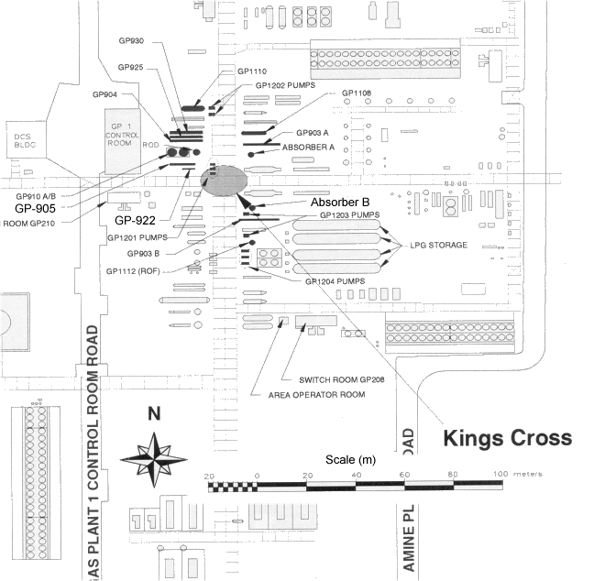
Figure 3. Plot Plan around GP-905 and King’s Cross junction

Regarding the source of fuel for the fire, the Commission concluded that the local inventory was only sufficient to fuel the fire … for up to two hours following the initial release, indicating that the fire was ultimately fed from sources outside GP1. The ESD system in GP1 was designed only to isolate the Longford plant from the major offshore pipelines, and the feed to the gas transmission line. It did not activate any isolation valves, apart from a valve on the dehydrators, within GP1. The consequence was that the entire volume of hydrocarbons contained within GP1 vessels and interconnecting piping existed as an uncontrolled source of fuel for the fires emanating from GP905 and GP922. … This weakness was recognised by a 1994 Periodic Risk Assessment (PRA) of GP1, but it appears that no action was taken to correct the situation.

Had the supply of flammable materials been isolated within minutes after GP905 ruptured, it is unlikely that any of the pipes in the piperacks would have failed as they did… The availability of these further sources to fuel the fire completely changed the dimension and scale of the accident.

ESSO’S SAFETY MANAGEMENT SYSTEM

Following an oil spill from the oil tanker Exxon Valdez in 1989 and against the background of a number of other disasters arising from the hazardous activities of companies other than the Exxon Corporation and its affiliates, Exxon developed a framework for the safe and environmentally sound operation of its various undertakings. The framework was called Operations Integrity Management Framework. Exxon Company International (ECI) had developed an 11 element management system guidelines:
Element 1 – Management leadership, commitment and accountability;
Element 2 – Risk assessment and management;
Element 3 – Facilities design and construction;
Element 4 – Information/documentation;
Element 5 – Personnel and training;
Element 6 – Operations and maintenance;
Element 7 – Management of change;
Element 8 – Third party services;
Element 9 – Incident investigation and analysis;
Element 10 – Community awareness and emergency preparedness;
Element 11 – Operations integrity assessment and improvement.

These combined with OIMF led to the Operations Integrity Management System (OIMS). OIMS is widely regarded in safety management circles as being of world-class standard. It embodies many of the most modern concepts of safety management systems and has been extensively copied by another major oil company…. an indication that it has wide credibility.

The Commission investigated deeply the implementation of the OIMS system at Longford and in its view established several omissions or deficiencies in implementation. The author’s of this paper put it to readers that, to the degree that they accept the Commission’s findings, that they might well recognise similarities in their own facilities to those described here. This is vital knowledge to share amongst the industry.

Briefly (noting that this is not simple) the Commission outlined its assessment of omissions or deficiencies as follows (4.1 through 4.8). The Operator, Esso Australia, did not agree with all these findings during the presentation of evidence, therefore the author’s have used only the words of the Commission itself.

4.1 Training
The accident on 25 September itself demonstrated the primary deficiency in Esso’s training. That deficiency lay in the failure of its training programmes, however implemented, to impart or refresh the knowledge required to operate GP1 safely in the conditions which existed on the day.

At no relevant time did any programme include training with respect to the hazards associated with the loss of lean oil flow, the hazards associated with the uncontrolled flow of condensate into the rich oil stream from the absorbers, the critical operating temperatures for GP922 and GP905, the circumstances in which brittle fracture might occur or the procedures for the shutdown or start up of GP1.

4.2 Operating Instructions
An example of Esso’s failure to implement OIMS is apparent from the state of the Longford Plant Operating Procedures Manual, which contained the operating procedures for GP1 and was located in the GPI control room. It was a controlled document and was identified by the OIMS Systems Manual as part of OIMS. The manual did not comply with the guidelines in critical respects. It did not contain any reference to the loss of lean oil flow and contained no procedures to deal with such an event. Nor did it contain any reference to GP1 shutdown or start up procedures or the safe operating temperatures for GP905 and GP922.

4.3 Operator Knowledge
The deficiencies in operator training and operating procedures were reflected in the evidence of what the operators and supervisors actually did on 25 September 1998… The collective experience of those present at GP922 on 25 September 1998 was more than 200 years at Longford and yet no one recognised the hazards associated with the plant conditions which culminated in the explosion and fire.

The operations manager at Esso…. agreed that the instruction given to operators “failed in arming them to recognise the significance of cold temperatures…there was clearly a lack of knowledge or understanding of cold temperatures.” He said he had no idea, before the accident, that a loss of lean oil flow for any length of time would be a hazard.

4.4 OIMS Self-Assessment
Element 11 of the ECI Guidelines, which were translated into Esso’s OIMS Systems Manual, required a “process that measures the degree to which expectations are met” and regarded that requirement as essential “to improve operations integrity and maintain accountability”.

An external assessment was carried out by a team … in March and April 1998. A report of the assessment was prepared and sent to Esso. The report noted that the assessment team had concluded that Esso had successfully applied OIMS and had a high level of management involvement and participation, presumably in that process.

These (and other) observations of the assessment team appear inconsistent with the Commission’s findings concerning the failure of Esso to implement its own systems, particularly in relation to risk identification, analysis and management, training, operating procedures, documentation, data and communications. The Commission can only conclude that the methodology employed by the assessment team was flawed in that the team failed to identify significant deficiencies in the extent to which “individual EAL Management Systems” conformed to the guidelines, particularly in relation to GP1, and were implemented.

4.5 Risk Assessment
The central importance of co-ordinated and planned hazard identification, assessment and control to the safe and efficient operation of a processing facility, is well recognised throughout the processing industry. The methods by which risk assessment and management were to be carried out were detailed in the Risk Assessment Manual (RAMS). The highest level required planned hazard identification and risk assessment to take place in various circumstances. These assessments embraced Periodic Risk Assessments (PRAs) which were to take place at intervals specified by RAMS; Quantitative Risk Assessments (QRAs) which were detailed risk studies carried out as needed to assess specific major hazard risks; and triggered risk assessments which were scenario-based assessments prompted by the happening of particular events. At the next level there were hazard identification techniques to be used by employees and management in the course of operations. These included the use of check lists, analyses based upon the question “what if?” and hazard and operability (HAZOP) studies, either prospective or retrospective, conducted when the need appeared to identify particular hazards involved in the operation of the plants. At the lowest level there were hazard identification “tools” to be used by operators to identify hazards and mitigate risk on a daily basis. These tools, or techniques, primarily comprised “step back 5x5” (stepping back five paces and pausing for five minutes to reflect upon likely hazards) and task analysis.

With the introduction of OIMS in the early 1990’s, there was a requirement for the carrying out of HAZOP studies as part of the design process for new plant. OIMS also contained provision for retrospective HAZOP studies on existing plant, should they be called for. Retrospective HAZOP studies were conducted for GP2 in September 1994, for GP3 in November 1994 and for the CSP in December 1995.

Esso recognised the particular significance of a HAZOP study for GP1, given the age of the plant, the modifications made to its initial design and the changes to design standards since the plant was built. These reasons grew stronger with the passage of time. Indeed, a HAZOP study for GP1 was planned to take place in 1995 and the cost of such a study was included by Esso in successive budgets during the years 1995 to 1998.

The HAZOP study planned for GP1 never took place…. In the end, no satisfactory reason was given in evidence for its deferral or abandonment.

The Commission was convinced of the value of a HAZOP…. it is inconceivable that a HAZOP study of GP1 would not have revealed factors which contributed to the accident which occurred on 25 September 1998. It would, for example have revealed the consequences associated with loss of lean oil flow and would have identified the procedures to be adopted in order to avoid dangerously low temperatures.

A Periodic Risk Assessment was carried out on GP-1, but the scope and depth of analysis was questioned by the Commission. Specifically it noted… the 1994 PRA was directed away from process-related hazards and concentrated on hazards caused by mechanical equipment failure and operator error. Scenarios addressing the consequences of “low temperatures”, “high level” and “no flow” were not used. Indeed, no scenario was used which included any of the process upsets which occurred in GP1 on 25 September 1998.

4.6 Relocation of Plant Engineers
Until 1991, engineers were stationed at Sale and worked at the Longford plant daily. In 1992, Esso relocated all its plant engineers to Melbourne as part of a restructuring of the company. The change appears to have had a lasting impact on operational practices at the Longford plant. The physical isolation of engineers from the plant deprived operations personnel of engineering expertise and knowledge which previously they gained through interaction and involvement with engineers on site. Moreover, the engineers themselves no longer gained an intimate knowledge of plant activities.

The Commission concluded strongly…There were no experienced engineers on site at the time of the accident on 25 September 1998. Such changes required a risk assessment in the Commission’s interpretation of Esso’s Management of Change System… Again, no such assessment was carried out.

One important loss of activity due to the move, in the view of the Commission, was a loss of engineer surveillance. Whilst originally part of their scope this became less after they moved to Melbourne and they tended to work more on engineering projects. However… plant engineers based in Melbourne made frequent visits to the Longford plant so that some opportunity for surveillance activities existed. Operators and plant supervisors now were taking the greater role in surveillance but their … work was focused on immediate production requirements rather than trend analysis or the analysis of recurring process problems. Whilst PIDAS data was stored the same was not the case for paper charts (70% of the data) …there was no system in place for preserving such records either for surveillance purposes or for accident investigation and analysis. The evidence was that charts, once used, were discarded by operators.

4.7 Incident Reporting and Analysis
A prior, unrelated incident, occurred on 28 Aug 1998, which led to many similar characteristics associated with the loss of Lean Oil circulation in GP-1. This was not investigated. Had the incident on 28 August 1998 been reported as it should have been, the danger of equipment becoming subject to dangerously low temperatures upon the loss of lean oil flow for any length of time would, in all probability, have become known as would the steps available to avert the danger. The failure to report this incident thus stands as another example of a failure in Esso’s implementation of its management systems.

4.8 Overall Assessment of Management System
Evidence was given that OIMS was a world-class system and complied with world’s best practice. Whilst this may be true of the expectations and guidelines upon which the system was based, the same cannot be said of the operation of the system in practice. Even the best management system is defective if it is not effectively implemented. The system must be capable of being understood by those expected to implement it.

Esso’s OIMS, together with all the supporting manuals, comprised a complex management system. It was repetitive, circular, and contained unnecessary cross-referencing. Much of its language was impenetrable.

The Commission gained the distinct impression that there was a tendency for the administration of OIMS to take on a life of its own, divorced from operations in the field.

However, the fundamental shortcoming was in the implementation of OIMS, as seen in the inadequate state of knowledge of Esso personnel of the hazards associated with loss of lean oil circulation in GP1 and of the actions which could be taken to mitigate such hazards.

Reliance placed by Esso on its OIMS for the safe operation of the plant was misplaced. The accident on 25 September 1998 demonstrated in itself, that important components of Esso’s system of management were either defective or not implemented.

- IMPLICATIONS FOR SEVESO II IMPLEMENTATION

The main lessons to be drawn from Longford relevant to Seveso II are, in the opinion of the authors, as follows:
- Safety Management System – incomplete implementation
- Knowledge Stewardship – insufficient on old plant
- Management of Change – organisational change not subjected to this procedure
- Audit and Review – opportunities to discover gaps were missed

- A Safety Management System must be implemented fully. The CCPS Committee on Technical Management of Process Safety (CCPS, 1989) was clear – it is better to implement all of the safety management system adequately than selected parts excellently and others not at all. The Commission accepted that OIMS was a world-class SMS, but queried its fullness in implementation. Clearly large parts had been implemented well, but those parts that had not been were the cause of the disaster.
- Risk Assessment must be founded on good Hazard Identification. No HAZOP had been done for GP-1 and thus the risk assessment that was carried out had omissions and limited scope. Many older plants have never been properly HAZOP’d and other companies should assess the implications of this omission.
- Knowledge and Competence are vital. Whilst very extensive operations knowledge was locally available the Commission significantly queried the absence of local process and materials engineering skills. This harks back to the Flixborough disaster finding that a key mechanical engineering post was vacant and thus a temporary modification was not mechanically checked. Esso did have those skills, thus the issue to address is whether having those available but not local is adequate. Esso made alternative arrangements involving IT linkages and easy travel arrangements. The Commission concluded that they were not. Downsizing, re-engineering, right-sizing are all important means to remain competitive, but the effect of these on competence should have been risk assessed. This is of particular importance to older plants where documentation is often not as good as for modern plants.
- Training and Operating Instructions. These need to be tightly linked to a detailed hazard identification and risk assessment. This is the key means to communicate fundamental process and materials knowledge to operating staff. Operating instructions should be linked to specific safety implications.
- An SMS once implemented must be rigorously audited. This requires an active and challenging Corporate function and also that the regulator does their job effectively. Regulations will come to nothing if the safety case so developed remains a collection of paper – active systems must verify it is being implemented and continuously maintained and updated (the “evergreen concept”). This activity should be budgeted (typical figures suggest ongoing investments of 25-50% of the initial investment). Both these suggestions are a challenge to current thinking. Many Corporate Safety Groups have been seriously downsized with operating assets given much greater autonomy. Similarly, many EU Regulators implementing Seveso I did not actively regulate the industry. They took the view that the development of a safety case was in its own right an adequate regulatory achievement. This is an important lesson.

REFERENCES

CCPS (1989) Guidelines For Technical Management Of Chemical Process Safety, Center for Chemical Process Safety: American Institute of Chemical Engineers, New York: 169 p. ISBN: 0816904235

Govt of Victoria (1999) The Esso Longford Gas Plant Incident, Report of the Longford Royal Commission, Govt Printer, State of Victoria (available on Internet)

Spouge, J and Pitblado, R (in press) Consequence modelling of the hydrocarbons fire at Longford, Australia 25 Sept 1999, Hazards XV Conference, Manchester April 2000, Hazard Symposium Series, Institution of Chemical Engineers, UK.

