DETERMINISTIC AND PROBABILISTIC APPROACHES IN RISK ANALYSIS
The Walloon Region's hybrid approach

G. Van Malder

Ministere de la region Wallone, Belgium, e-mail: g.vanmalder@mrv.wallonie.be

introduction

Time and again I have heard discussions or read articles that made use of either deterministic or probabilistic approaches and took clear positions in favour of one or the other of these two types of approaches. I have often been asked by industrialists or their consultants which approach was used in the safety studies demanded by the Ministry of the Walloon Region, and each time I have to explain that since the first Seveso Directive the Ministry of the Walloon Region has held a non-aligned position, meaning that it gives priority to clear discourse and leaves each applicant free to find the most convincing arguments to justify authorising a dangerous activity. The following talk explains the reasons for choosing one type of reasoning over the others and gives an example on how, in applying for a permit to conduct a dangerous activity on a given site and from the same licensing authority, the author of a safety study should perform a deterministic or probabilistic analysis, depending on the case.

The safety study's purpose

The basic purpose of a safety study is to prove that a reputedly dangerous activity will be conducted with all the necessary precautions so as to dispel the fear of a disaster. Clarity must be its chief characteristic. The arguments that are brought up must be within the grasp of any normally educated person, not just the inner circle, for they must be understood by a variety of decision-makers, and also perhaps above all, reassure the people who are directly concerned. A rule that should be imposed on any official called upon to decide on a dangerous activity is to be able of restating, in his own words, the reasons for believing that an activity is safe. If the official cannot do that, he has the duty to ask for additional explanations, if a doubt subsists, or to reject the application if the project appears to be too risky. To be convincing, the study must bring up all of the events that could be feared, regardless of their likelihood or seriousness, and explain for each event why one would believe that the activity will not cause a disaster.

The right reasons for considering a risk acceptable

Experience has shown that there are four ways of justifying a decision to carry out a dangerous activity and that they have very different chances of gaining unanimous acceptance, depending on whether they call upon pure logic, scientific calculations, or statistics.

3.1 The feared event is physically impossible
The most radical way to reassure the people concerned is to prove that the activity in question uses inherently safe techniques and that the feared accident is physically impossible. In such cases, the message is almost always very easy to get across, because it calls upon basic logic. For example, it is very easy to get people to understand that a buried tank cannot explode if it comes in contact with a flame because it is impossible to keep a flame going in the ground in the absence of air. Similarly, everyone can understand that a tank's wall cannot be pierced by a missile if it is protected by earth of one metre depth.

3.2 Dangerous effects of the feared event will not reach any crowded or populated areas.
When the accident that is feared is not logically impossible, it is still easy to get and ground a decision to allow the dangerous activity if one can prove that, even in the worst-case scenario, the scope of the dangerous effects is limited enough not to reach crowded or populated areas. This type of argument may be used, for example, to get acceptance of the risk of a flash fire following a flammable gas leak at a loading station that is correctly equipped with means to limit the leak's flow rate and duration. In this case, the approach is deterministic. Calculations that are based on the laws of physics will be used to prove the safety around the installations. Even if the calculations may be marked by great uncertainty, the experts will always manage to agree on a distance that everyone is sure will not be exceeded.

3.3 The feared event is slow enough to guarantee that the population can be kept out of harm's way.
This third type of argument may be used for feared events that are not logically impossible and the harmful effects of which are of large enough magnitude to reach crowded or populated areas but unfold slowly enough to guarantee that they will not have any catastrophic consequences. This applies, for example, to the smoke generated by fires that spread slowly enough to give nearby residents enough time to close their windows and doors or evacuate the premises if necessary.

In this case, the proof of safety is usually based on empiricism, if the phenomenon is well known, and, if need be, on physical calculations such as combustion and evaporation rates.

3.4 The probability of the feared event's occurring is small enough to believe that it will never occur.
The very small probability of occurrence may be used to justify a favourable decision only as a last resort, if none of the preceding arguments can be invoked. The main reason for putting this argument in last place is that it is the least convincing and most difficult to develop. It is the least convincing because:

- aversion to risk varies greatly from one individual to the next;
- the probabilistic projections that are applied to events that are rare or never seen are only constructs of the mind;
- the available statistical data often have only tenuous connections with the case studied, and the margins of error are considerable;
- even a highly improbable event can nevertheless occur tomorrow.

It is also the most difficult to develop because it requires very fine analysis, strict logic, and the use of often uncertain figures. Still, despite this approach's known weaknesses, it is used intensively, for rejecting it would lead to refusing scads of reputedly dangerous activities that are no more dangerous than other better-known and generally accepted activities such as urban gas distribution or maritime passenger transport.

To be understood by the largest number of people, we talk about the probability of “dangerous effects” occurring in places used by people rather than “expected value of death”, as is usual elsewhere. This concept has many advantages, among them:

- a more accurate perception of the true fears of the people, who do not want a disaster at all and are not willing to accept concessions according to the number of fatalities. If the risk of a disaster is deemed acceptable, it is always because of its probability, not because of the disaster's magnitude;
- it takes account of the non-lethal consequences (physical and mental trauma and injury);
- it simplifies the study by removing what is most open to contestation, for there are effectively too many unpredictable givens to allow the establishment of a true correlation between the physical effects of an accident and too few observations of major accidents to allow serious projections.
So, for example, it is much easier and certain to content oneself with estimating the probability that a building will be subjected to dangerous pressure overloads than to estimate the number of people who would die if the building collapsed.

When it comes to buildings' stability, it is also worthwhile to confine oneself to the risk of dangerous effects, in the interests of quality communication. The situation of a building's collapse is already unacceptable to the residents. Speculating about the number of deaths to judge the acceptability of a risk would imply that the Authority considered it acceptable for the resident to be buried under the rubble of his home, as long as he survived. Such an attitude would create doubt as to the protective role that the citizen is entitled to expect from public services.

To sum up, the procedure used in safety studies consists in asking four questions in the order of the most reassuring answers, as follows:
- Is the feared event physically impossible?
If it is not, then:
- Is the magnitude of the dangerous effects limited enough not to reach crowded or populated areas?
If it is not, then
- Is the pace of the feared event slow enough to make it possible to get the threatened population out of harm's way?
If it is not, then:
- Is the feared event's probability low enough to believe that it will not occur?
A single 'yes' answer will be sufficient to justify the decision to grant the permit and the study's authors know that they can end their proof as soon as they have a good reason. This practice saves time for the study's authors and evaluators alike.
The decision-making process is illustrated by the figure 1 diagram.
 | Is the planned technique  inherently sure? | Yes  ⎯⎯→ | No risk at all | ⎯→ | P  E  R
 | ↓ No |  |  |  | M  I
 | Is the range of harmful effects too short to reach the  public ? | Yes  ⎯⎯→ | The risk is under control due to safety distances | ⎯→ | T  M  A  Y
 | ↓ No
 | Is the evolution of the accident surely slow ? | Yes  ⎯⎯→ | The risk is under control due to the emergency plan | ⎯→ | B  E
 | ↓ No |  |  |  | G  R
 | Is the probability of the accident very low ? | Yes  ⎯⎯→ | The risk is not totally under control but very unlikely | ⎯→ | A  N  T  E  D
 | ↓ No
 | Risk is not acceptable | ⎯⎯→ | Permit must be | denied
Figure 1: Decision-making process

The case of Energysud's depot at Naninne

This case study concerns a depot of bulk propane gas and bottled gas for household use. More than 200 metric tons of gas is stored on the site. The firm is thus required to conduct a safety study to renew its operating permit.

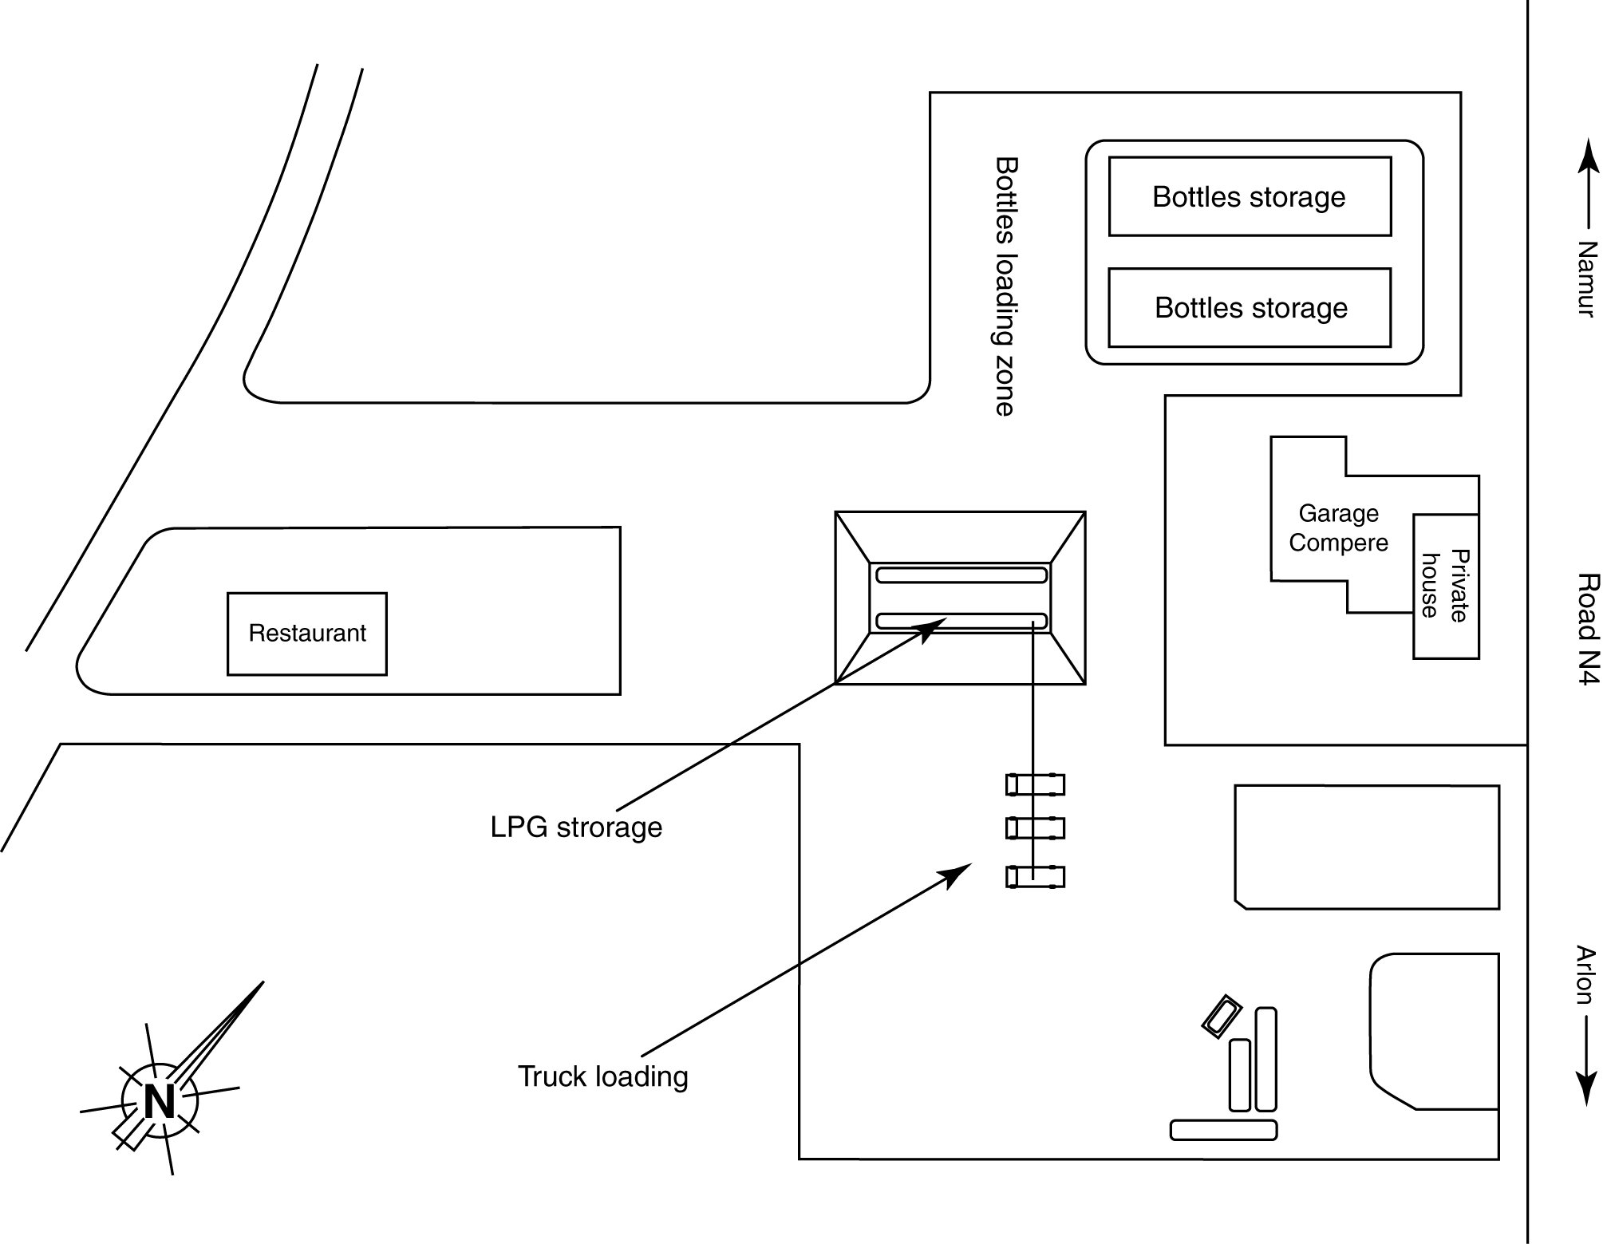
Figure 2: Propane Gas Depot

We can see (Figure 2) that the immediate neighbourhood comprises crowded or populated areas and many sources of ignition. If we take the lorry loading stations as our reference point, these sources are:

- a maintenance shop 50 m north of the reference point;
- a national motorway 70 m north-east of the reference point;
- a roadside restaurant 100 m south-west of the reference point; and
- a computer services company 150 m south of the reference point.

This is neither the best nor the worst situation that we have to manage.

The method used in the Walloon Region consists in identifying the installations likely to release large amounts of hazardous substances and to analyse the causes and consequences of a series of feared events associated with each dangerous installation. In the case of this depot, the dangerous installations are:

- the propane storage tanks;
- the 25-ton tank-trucks that supply the depot;
- the unloading stations for these tank-trucks;
- the 10-ton trucks for distribution to customers; and
- the loading stations for these trucks.
The feared events are:
- BLEVE of a bulk propane storage tank;
- BLEVE of a 25-ton tank-truck;
- BLEVE of a 10-ton tank-truck;
- a slow leak in the bulk storage tank;
- a slow leak in the tank-truck loading station;
- a slow leak from a supply tank-truck.
The study reached the following conclusions:

For a BLEVE of a bulk storage tank:
The study showed that the event was not to be feared, for it is not possible to overheat the tank's contents or pierce the tank's wall by means of a flame or missile impact, for the tanks are covered by earth of a metre depth. In this case, the physical impossibility of the feared event's occurring is evidenced. If an author feels it is a good idea to calculate the scope of the dangerous effects of a BLEVE, should one occur, this information is not sent on, for it would confuse people and make them forget that the feared event is strictly impossible.

For a BLEVE of a tank-truck:
The study shows that the event is not logically impossible and that the effects of a BLEVE would reach crowded or populated areas. Since one cannot guarantee that the people exposed to the risk can be kept out of harm's way, the only way to demonstrate that the risk is acceptable is to establish the very low probabilities of the precursor events occurring and of their leading to a disaster.

The precursor event is always a massive propane leak. The probabilities, calculated used the fault tree method, give:

- 1.8(10⁻⁶)/year for the loading operations;
- 1(10⁻⁶)/year for the unloading operations; and
- 6.9(10⁻⁶)/year for the leaks in the tanks and pipes.

The probability of a massive leak is thus estimated at 9.7(10⁻⁶)/year. This figure is relatively low, but not enough to reassure one about the probability of a disastrous outcome
If we look at the event tree (Figure 3) and conditional probabilities of the various possible developments, we notice that:
- the probability of a cloud being ignited immediately is estimated at 0.30, given the distribution of wind speeds and directions;
- the probability that a tank-truck will be parked next to a tank-truck on fire is 0.015, based on tank-truck and lorry movements in the depot;
- the probability that a jet fire at the leak site will be directed at another tank-truck is 0.1.
As the analysis shows that these three conditions must be met for a BLEVE in a tank-truck to occur, we can conclude that the conditional probability of a disastrous outcome, based on the particularities of the firm studied, is 4.5(10⁻⁴). The risk of a tank-truck BLEVE’s occurring is thus set at 4.9(10⁻⁹)/year. This is well below the indifference threshold of the public-at-large.
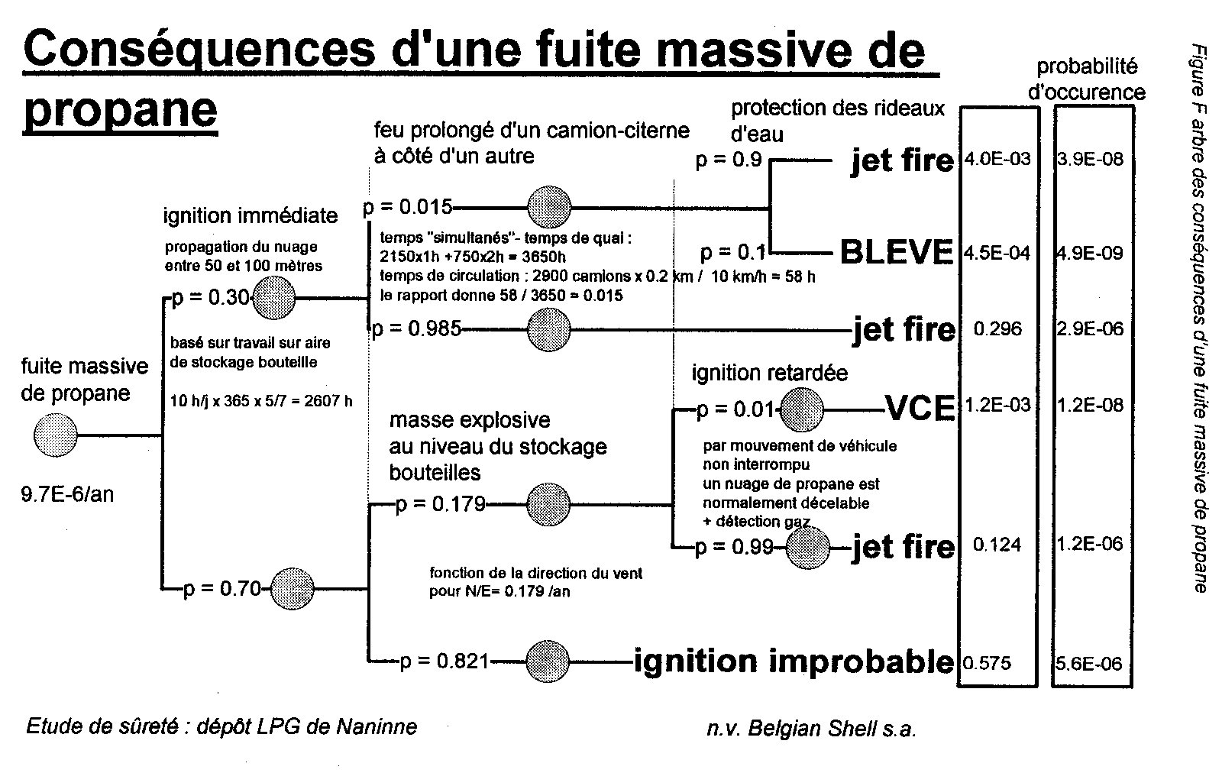
Figure 3: Event Tree of massive propane leakage

For the risk of (air-gas) vapour cloud explosions:
Another development that can have serious consequences outside the depot is the VCE that could occur if a vapour cloud formed in the bottle stockyard and an engine ignited the vapour cloud after a large explosive mass had built up. This case supposes a weak wind blowing towards the stockyard and the gas detection system's failure. The conditional probability of meeting both these situations was estimated to be 1.2(10⁻³) and the risk of a VCE thus 1.2(10⁻⁸)/year.

For the risk of a flash fire:
The most probable event to be feared is a flash fire, the conditional probability of which was estimated to be 0.296(10⁻⁶), yielding a risk of 2.9(10⁻⁶)/year. Although this probability is low, it could be deemed unacceptable by some people. For this reason, we prefer to present the limited scope of the dangerous effects, which would affect only the people working on the company's premises and possibly the individuals who are the source of ignition on the road or in the repair shop, first. Only later do we put forward the argument that the risk of a serious accident for the rare people concerned is very small.

SUMMARY

To sum up:

- A safety study for a site such as Energysud's depot considers both the causes and the effects of the feared events.
- The reasons for authorising a dangerous activity are always based on the risk of its engendering a disaster.
- The risk must always be very low and may be explained by the low probability of the accidents occurring or the low probability of exposure to the accident's effects.
- To make it easier to understand the reasons for authorising the dangerous activity, the arguments always bring up the component that causes the probability to be very low or even nil.
- If the probability of the accident's occurrence or exposure to its effects is strictly nil, we prove this by means of quantitative or qualitative logic (deterministic approach).
- If neither of these two probabilities is nil, we rely on the calculated probabilities to estimate the probability of a disaster (probabilistic approach).
- The lowest probability is always the one to be stressed.
- We never speculate about the number of probable deaths.
- A disaster is never quantified, given that

a disaster risk will be acceptable due to the disaster's probability, but the disaster itself, is never acceptable.

