Bureau Veritas Safety Process Program

Kerhoas

Industry Division Bureau Veritas
Risk Manager
17 bis, Place des Reflets
La Defense 2. 92400 Courbevoie

Paris – France

Extended Summary

1. Why to dedicate a specific management to safety
Several accidents surveyed have emphasised that root causes of work accident are organisational failures. Since 1982, in the European Union, 90% of work accidents are due to management failures. Therefore, the new European Directive related to hazardous materials makes mandatory to organisations to implement a Safety Management System. Likewise, in Finland, 46% of fatal accidents are due to the lack, incompleteness or wrong application of work instructions.

How to integrate this new organisational issue when the concern to safety is usually restricted to the sole verification of compliance with statutory requirements?

Aware of the important role that safety plays in their business efficiency, more and more companies are now initiating safety management approach. To answer this growing request from organisations, Bureau Veritas has developed a dedicated Safety Process Program (SPP) supported by a software tool named VerEval. This program allows us:

- To assess the safety level on general grounds as well as in any specific field;

- In the short term, to improve the safety level on the most critical points by implementing immediate corrective actions;

- In the middle and long term, to implement, to maintain and continuously to improve the most adapted Safety Management Standard.

2. Bureau Veritas Safety Process Program tools

Safety checklists
All our diagnoses and audits are guided by the standardised audit checklists and a library of audit questions related to safety programs.
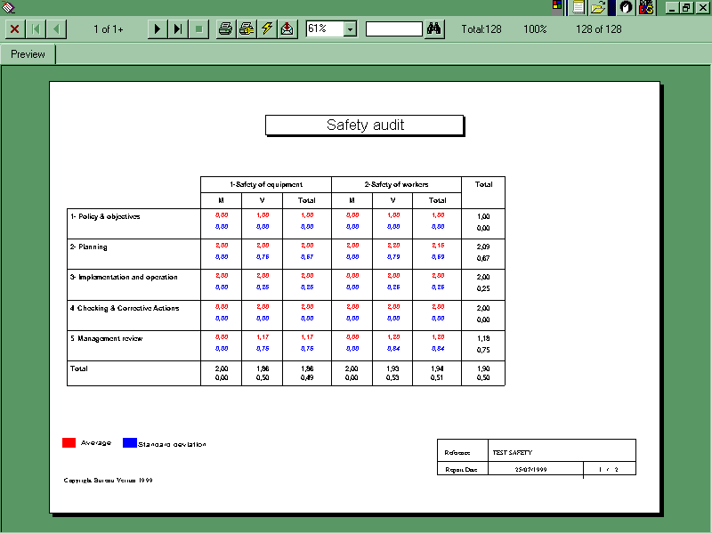

Checklists are made of questions that cover the following aspects:

- mandatory safety requirements and voluntary safety good practices
- organisational and technical safety aspects
- safety of equipment and employees

and also the main statutory requirements and industry initiatives such as:

- OSHA PSM 29cfr 1910.119
- EEC Seveso II Directive
- BS 8800
- Responsible Care program
- SafetyCert®
- EEC Health & Safety of workers Directives
- EEC critical equipment Directives

Seveso II check-list
The Seveso II check-list is made-up of around 200 questions which cover the following aspects:

- Policy
- Risk assessment
- Legal and other requirements
- Objectives and performance criteria
- Safety management program
- Management representative
- Resources
- Training, awareness and competence
- Internal and external communication
- Documentation
- Purchasing
- Process control
- Management of change
- Emergency preparedness and response
- Monitoring and measurement
- Corrective and preventive actions
- Records
- Internal safety audit
- Management review

VerEval software
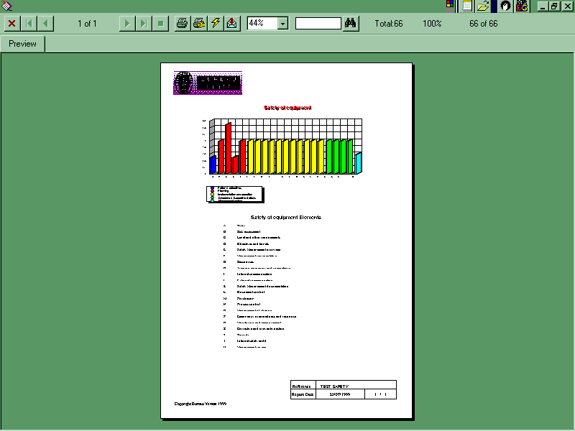
Associated to the checklists, we use the VerEval software. It has been developed in order to facilitate and optimise the daily work of our consultants and auditors. And, thus, they are able to spend more time with the client to find out the best solutions to improve the actual situation.
The main function of VerEval is to manage all data issued from audits in such a way that we are able to provide our client with several types of outputs such as:

- Graphical and numerical profile
- General table of averages
- Pinpoint of critical functions
- List of remaining deviations to obtain a private certification and/or award
- Detailed diagnosis outputs

Due to its power, SMS can be used in a wide variety of measurements:

- System and procedures evaluation: content as well as application on site
- People behaviour assessment: knowledge and skill as well as attitude
- Plant and equipment condition inspection: adaptation as well as physical condition

