The "SEVESO" EXpert System " S E V E X " : An Integrated Approach for Off-Site Effects Analysis & Effective Emergency Planning

A. DUTRIEUX ª and G. VAN MALDER ^{b}

ª ATM-PRO s.p.r.l., Rue Saint-André, 5, B-1400 Nivelles, Belgium
(Tel.: + 32 67 84 33 04 / Fax.: + 32 67 21 36 28 / Email: alexis.dutrieux@skynet.be)

^{b} Major Accidents Prevention, Ministry of the Walloon Region, Jambes, Belgium.
(Tel.: + 32 (0)81 33 61 40 / Email.: G.VanMalder@mrw.wallonie.be)

Abstract
According to the European SEVESO Directives (cfr. 82/501/EEC & 96/82/EC), the Ministry of the Walloon Region (Belgium) is responsible for the external safety around areas of high risk activities in its region of competence. This includes the delimitation of risk areas where emergency planning must be prepared.

The general purpose of any emergency plan is to reduce the consequences of an accident, not only by rescuing the victims as fast as possible, but also and preferably by reducing their number. This goal can be reached by giving information about the behaviour to adopt versus the danger in order to avoid health damage to the population and the rescuers (police forces,...).

The basic concepts of this emergency planning were defined by the Walloon Region jointly with the Belgian Civil Protection.

The software, requested to compute and to plot risk areas, is developed in a multidisciplinary project called SEVEX ( SEVeso EXpert ) funded by the Walloon Region. This project involves three Belgian Universities (Faculté Polytechnique de Mons, Université Catholique de Louvain, Université de Liège) and SOLVAY. The PC windows version of the SEVEX software is developed and marketed by ATM-PRO, owner of the exclusive rights on SEVEX.

The most inventive characteristic of the SEVEX software is a three dimensional dispersion model which takes into account the topography and the land use around the hazardous activity.

THE WALLOON POLITICAL CONTEXT

When transposing the 82/501/EEC Directive, the Walloon Government named the Minister of the Environment for the Walloon Region for determining risk areas around hazardous activities and for giving all the useful information for emergency planning. Those two liabilities have led to achieve an efficient method to work out emergency planning and to develop an appropriate tool.

Entrusting the determining of risk areas to the Authority offers many advantages. First the Authority in charge of the Safety Report has a good knowledge of the hazards. Second it is much more neutral than the industrials who may fear the consequences of confessing how catastrophic some accidents may be. And third, concentrating all the effects assessment on the same office increases the expertise and justified the investment in the most advanced software.

THE NEED FOR EMERGENCY PLANNING

In a crisis situation a lot of decisions are very difficult to take because there is a conflict between efficiency and safety requirements which can be summarised as presented in Table 1:

Table 1. Conflicting requirements in emergency conditions
Efficiency requirements Safety requirements
Restriction of isolation perimeter Enough distance from harmful effects.
Immediate decisions Assessment of their consequences.
Unanimous approval Checking assumptions.
Fully detailed, accurate and steady Taking into account the uncertainty
instructions about source term and weather conditions.
These conflicting requirements are utterly irreconcilable when it comes to draw up a reliable and detailed plan under emergency conditions. But they can be reconciled provided all decisions have been proposed, criticised and tested beforehand.

The option chosen by the Walloon Region includes developing to a maximum degree the anticipate decision-making process and building up a directory of detailed plans which can be implemented immediately.

Common sense leads, nevertheless, to let take in real time, all the decisions easy to take and fully related to local or temporary data. They are, obviously, technical reasons for anticipating events because in case of accident, data on the source term are hardly (or never) available, and deciding what is the best to do might take very long time.

There is also a psychological reason for being prepared for an emergency in case of threat of an accident. Without a plan, the Authorities cannot warn the public if no one knows what to do and the operators who are loosing the control of the situation won't warn the Authority if it can just lead to panic. Everybody would be ashamed and wouldn’t dare anything. With a plan, everybody would be self-confident and would dare to start the emergency plan in advance.

THE NEED FOR RISK AREAS

The general purpose of any emergency plan is to reduce the consequences of an accident not only by rescuing the victims as fast as possible but also and preferentially by reducing their number. This goal can be reached by giving information about the behaviour to adopt versus the danger (see table 2) in order to avoid health damage to the population and the police forces.

Table 2. Adopted behaviours versus danger
No danger Refraining from modifying one's behaviour.
Low risk of health damage Depending on one's own vulnerability or personal interest, choosing to shelter or expose oneself cautiously.
High risk of health damage Sheltering oneself in an air-tight building or
outside avoid entering the buildings in the danger zone.
High risk in the buildings Evacuating to safer places.

The most efficient way to let people know what to do somewhere is to draw maps of the different zones defined by the enjoined behaviour.

It must be noticed that all the cautiousness rules valid for warned and healthy people are also valid for the rescuers and the police forces who have to achieve their tasks without any particular safety equipment.

The first consequence is that the isolation perimeter held by the police forces to control the access of the high-risk zone may be located close to the limit of the two zones on the safer side of the borderline, without risk of disablement for the police. The second consequence is that the limit where no self-exposure would be allowed can be materialised by the whole checkpoints of the isolation perimeter without any risk of confusion for the exposed part of the population.

MANAGING THE UNCERTAINTY

One of the biggest challenges is to draw unambiguous and steady plans based on assumptions about very unlikely accidents in random circumstances. An issue to this problem has been round by considering several cases in several weather conditions and assessing their effects in order to shift out the worst scenario.

Because it is always possible to determine the conditions leading to the heaviest effects it is finally possible to draw up a steady detailed plan valid for some cases in the worst conditions and, of course, valid for better conditions too.

This philosophy can be criticised for the importance given to the safety versus efficiency and some would prefer average assumptions to worst assumptions (see table 3) in order to reduce the size of the zones to control. But experience has proved that effective planning cannot be drawn up as long as each responsible leader of a staff has a doubt about its safety and there would be probably the same problem to work out an emergency plan based on average assumptions if the rescuers had too few confidence in their own safety.

Table 3. Some examples of worst assumptions
Breach section in a pipe ⇒ pipe section.
Mass release from a vessel ⇒ whole vessel contents.
Weather condition (day-time) ⇒ overcast sky.
Weather condition (night-time) ⇒ clear sky.
Wind speed (continuous release) ⇒ lowest limit of model validity.
Wind speed (instantaneous release) ⇒ which bears concentration
furthest.

The other and more judicious way to increase confidence in determining risk areas is to resort to advanced models which take into account the reality of the surroundings and the wind field as well. That is the reason why SEVEX, a high-end integrated model, has been developed by the Walloon Region to fulfil its duty in emergency planning.

THE SEVEX TOOL

SEVEX (SEVeso EXpert) is an integrated software especially developed to comply with the European Directives (cfr. 82/501/EEC & 96/82/EC), so called "SEVESO DIRECTIVES". Starting from the data about credible accidents given by the safety studies, SEVEX is a unique tool to determine relevant zones for anticipate planning.

The initial development team involved 5 partners : (1) Faculté Polytechnique de MONS for the Source Term Model, (2) Université Catholique de LOUVAIN, for the wind field Model, (3) Université de LIEGE, for the 3 D - Dispersion Model, (4) Solvay S.A., for the prototype development, and (5) Association Informatique Hennuyère, for geographical data. ATM-PRO, which owns the exclusive licence rights on SEVEX, developed the PC windows version of SEVEX and is now marketing this new technology.

The source term model : SEVEX-SOURCE.
SEVEX-SOURCE, developed by J.M. LEVERT and C. DELVOSALLE at FACULTE POLYTECHNIQUE DE MONS, is a user-friendly software which can operate separately to compute physical effects or can be linked to a 3-D dispersion model and/or a geographical data base in order to draw risk areas onto scanned road-maps.

The programs handle: gas liquid and 2 phase flow rates, jet dispersion, aerosol vaporisation, pool formation and evaporation, dense gas dispersion, Gaussian dispersion, vapour cloud explosion and fireball thermal radiation (see figure 1).

The up-to-date calculation codes were steadily validated with the experimental results available. Special attention has been paid to help users to solve transient release cases.

5.1.1 The wind field model: SEVEX-MESO.
The SEVEX-MESO model, developed by G. SCHAYES at Université Catholique de Louvain, is a wind and vorticity model in the boundary layer which takes into account the relief and the roughness of the terrain and the time varying heat exchanges. The model computes wind speed, wind direction, vorticity and temperature at several heights over a square of 21 km x 21 km, down wind the release source (see figures 2&3).

This model which is purely theoretic solves the Navier-Stokes equations and the convective and radiative thermal exchanges from an altitude of 2.000 m down to the ground and has been validated upon three hilly sites of the Walloon Region.

Comparison between the model and physical measures are pretty good in neutral weather conditions, satisfactory in stable conditions and hardly impossible in unstable conditions. By chance, as neutral condition is a more conservative assumption, the unstable conditions have not to be taken into account for anticipate emergency planning.

Computations are made for different geostrophic wind speed and wind direction for cloudy days and clear nights. The detailed results are stored in an internal data bank and re-used in the 3 D dispersion model.

The 3 D dispersion model: SEVEX-TOXIC
SEVEX-TOXIC, developed at Université de LIEGE by Prof F. RONDAY e.a., is a Lagrangian dispersion model which simulates passive transportation and dispersion of particles of toxic substances at a rate and in a state given by the SEVEX-SOURCE model.The model runs with several different wind fields samples taken from the SEVEX-MESO results data bank in order to calculate the concentrations fields for the different weather conditions. Isopleths curves for the relevant concentrations are drawn for each weather conditions studied at several heights above the ground in the range where people can be exposed. To deal with the lowest wind speed in the validity limits of the dispersion model, calculations are made at fixed time in order to determine the maximum distance of the danger versus time. When there is no more confidence in concentration calculations in stillness conditions, SEVEX gives an answer in term of certainty about the minimal delay between release and danger at a given distance of the source.

A validation of the whole methodology has been performed in order to make sure that the limits of relevant concentrations given by SEVEX are not exceeded in reality. Practically, computed concentrations are compared with measured concentrations taken from meso-scale experimental campaign results data banks.

The graphical outputs
The only usable output for a 3 D dispersion model is a graphical output. In order to gather all the useful information on the same sheet of paper, SEVEX prints a map of the various risk areas on the right side of the sheet and information about risks on the left side. The risk areas are the envelope curves for all the scenarios processed with the same emergency plan. Several scenarios are simulated by varying parameters within some limits like the wind speed, the wind direction in a definite angle, the source location. These envelope curves are plotted on a background which is a scanned road-map at a scale of 1/100.000.

The different risk areas and the related adopted behaviours can be recognised by their colours, an example of plotted risk areas is shown in Fig. 4. The information on the risks related to the studied accident are gathered in a form available in 4 languages (English, French, Dutch and German) (see Fig. 5).

VALIDATIONS

The Ministry of the Walloon Region needed some guarantee about the realism of such an inventive model before using it for regulatory purposes. No large-scale release could be envisaged in a country (as inhabited) as Belgium and the only way to assess the validity of the linked models was assessing the validity of each module.

Validity of the SOURCE modules
The various modules of SOURCE were validated by comparing computation results to experimental measurements or accidental damages.

The dense cloud model has been compared to the experimental results of the Tortoise Desert experiments (ammonia release - Fig. 6) and the Latten experiments (propane release - Fig. 7).

The explosion model has been compared to the pressures inferred from the damages of the explosion which occurred in La MEDE - FRANCE 1992. The BLEVE model has been compared to the observations in La MEDE and in KINGMAN - ARIZONA in 1973 (table 4).

Table 4 : Comparison between fireball diameter, duration and radiation calculated by SEVEX (column 1) and assessed by experts ( column 2).
 | SEVEX | Expert | Relative error
ACCIDENT OF "LA MEDE" - France 1992
Diameter of the fireball (m) | 61 | 60 | 2 %
Duration of the fireball (s) | 4.8 | 4 | 17 %
Surface radiation intensity (kW/m²) | 325 | 300 | 8 %
ACCIDENT OF "KINGMAN" - ARIZONA USA 1973
Diameter of the fireball (m) | 196 | 187 | 5 %

6.2 Validation of the MESO-module
Calculated wind speeds and wind directions were compared to measurements in two different places of the same simulated wind field. Three hilly sites were chosen and for each of them comparisons were made between the conditions above the plateau and at 10 m above the bottom of the valley.

For stable and neutral conditions the difference between calculations and measurement were rather small. No comparison was possible in unstable conditions as the results were too scattered. This was not a real problem because unstable conditions are favourable for the dispersion and SEVEX is only interested in the worst conditions.

The Fig. 8 and 9 show the comparison between calculated and observed wind speed and wind direction in Jemeppe-sur-Sambre (in the valley) and Temploux (on the plateau).

Validation of the Lagrangian dispersion model
Comparison were made with data from the Karlsruhe's experiments performed in 1977. Wind fields were simulated with the same geostrophical wind and the releases had the same flow rates.

In order to assess the reliability of the methodology, isopleths were plotted with an increasing ratio of 1; 3; 10 and the sensor where the measured concentration did not exceed the calculated one were counted as valid results and those where the measured concentration exceeded the calculated one was counted as defaults.
Based on 8 experiments and about 250 concentration data the reliability of the model is assessed. The percentages of valid simulated concentrations vary from about 90 % to 99 % when a safety coefficient of 3 is applied.

REFERENCES

1. J-M. LEVERT, C. DELVOSALLE, F. BENJELLOUN. Manuel d'utilisation du logiciel SOURCE Version 3. 0. Faculté Polytechnique de Mons, Avril 1994.
2. J-M. LEVERT, C. DELVOSALLE, F. BENJELLOUN, F. BROGNON, P. MWGUET. Méthodes et Outils pour la quantification des conséquences d'accidents dans l'industrie chimique. Rapport final, contrat de gré à gré réf. MH/PVG/100593NO2 entre l'Etat belge et la Faculté Polytechnique de Mons, Juillet 1994.
3. C. DELVOSALLE, J-M LEVERT, F. BENJELLOUN, G. SCHAYES, B. MOYAUX, F. RONDAY, E. EVERBECQ, T. BOUROUAG, J-P. DZISIAK. Major industrial hazard : the SEVEX project - source terms and dispersion calculation in complex terrain. Presented at the 20th International Technical Meeting on Air Pollution Modelling and its applications, Valencia (SPAIN), 29 nov. - 3 déc. 1993.
4. F. BENJELLOUN, C. DELVOSALLE, J-M. LEVERT. Les industries à risques majeurs en région wallonne, Vol. I et II. Rapport de synthèse, convention SEVEX, Janvier 1992.
5. G. SCHAYES, B. MOYAUX. Région wallonne, Vol. 2. Rapport de synthèse, projet SEVEX, 1992.
6. T. BOUROUAG, J-F. DELIEGE, E. EVERBECQ, F. RONDAY. Les industries à risques majeurs en Région wallonne, Vol. 4. Centre Environnement - Université de Liège, 1992.
- F. RONDAY, T. BOUROUAG, E. EVERBECQ, J-P. DZISIAK. Validation de la méthodologie de délimitation des zones à risques développée dans le cadre SEVEX. Centre Environnement - Université de Liège, 1995.

FIGURES

Figure 1 : Various models linked in SEVEX software

Figure 2 & 3: Wind field close to the ground for a 2 m/s N-E synoptic wind applied to the topography given by the black contours (l.h.s.) and within the 3-D view (r.h.s.).

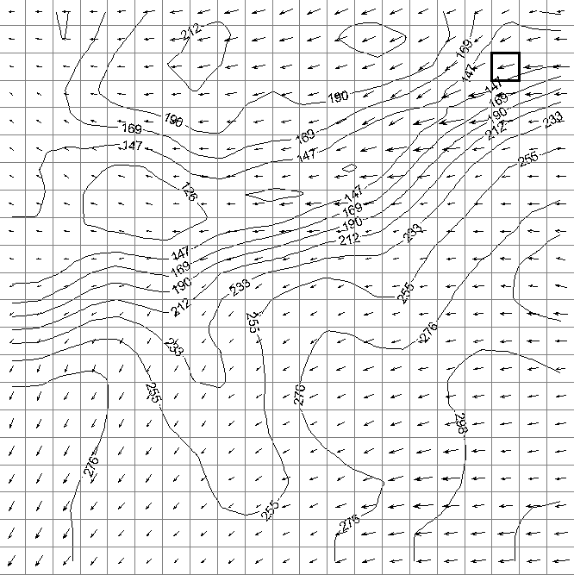
⇐ North is upward (portion of the whole domain)

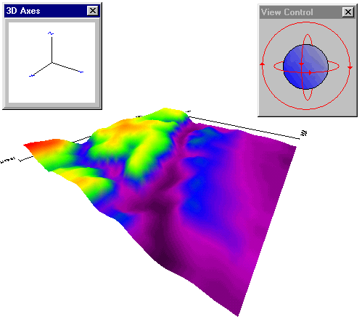
⇑ North towards LR corner (Whole domain)

Figure 4 & 5 : Samples of Accident and Hazards information form & Map of risk areas
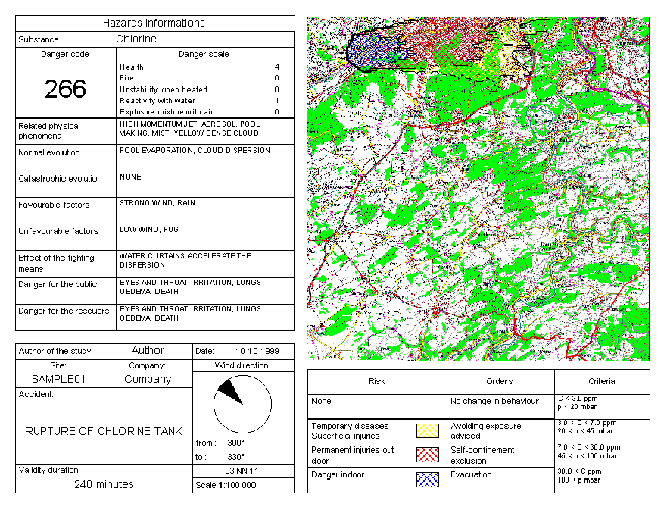
Figure 6 : Comparison between SEVEX and the Tortoise experimental results

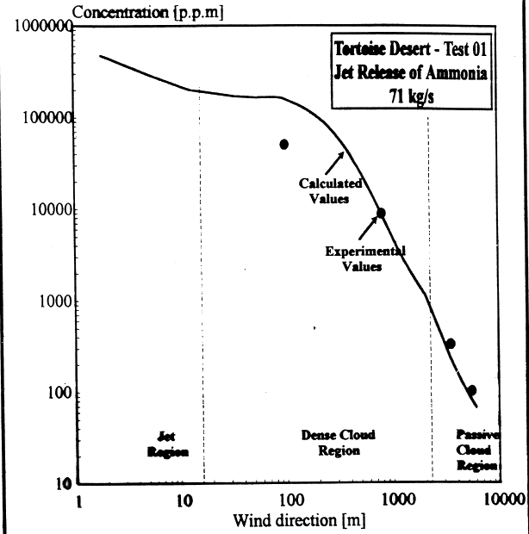
Figure 7 : Comparison between SEVEX and the Latten experimental results.

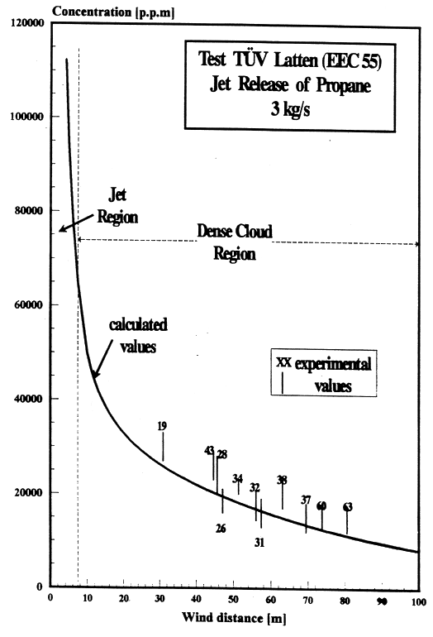
Figure 8 & 9 : Comparison between calculated and measured windspeed (9) & Comparison between calculated and measured wind direction (10) . ( (0) Temploux = plateau / (+) SOLVAY = valley)
