An Approach to the Assessment of Domino Accidents Hazard in Quantitative Area Risk Analysis

Valerio Cozzani and Severino Zanelli

Dipartimento di Ingegneria Chimica, Chimica Industriale e Scienza dei Materiali, Università degli Studi di Pisa, via Diotisalvi n.2, 56126 Pisa, Italy

1. INTRODUCTION

The severity of accidents where propagation effects took place, generally named as "domino" or "knock-on" accidents, is well known [1-4]. The European Community "Seveso-II" Directive (Directive 96/82/EC) [5] requires to assess "domino" accident hazards inside and outside the industrial sites that fall under the obligations of the Directive. Moreover, the Italian implementation of the Directive (DL 334/99) also requires the comprehensive quantitative risk analysis of areas where a high concentration of industrial sites is present, in order to assess the potential hazards due to the interaction of multiple risk sources in a narrow area.
The development of land use planning criteria for the reduction of industrial hazards for the population calls for the application of quantitative area risk analysis (QARA) methods [6]. However, available QARA techniques are mainly derived from quantitative methodologies for the analysis of single risk sources. Thus the main limitation of the QARA techniques currently available is in the correct analysis of the effects of the interaction of the different risk sources present in a narrow area. In particular, specific quantitative criteria for the estimation of "domino" or knock-on accidental scenarios are still lacking, even if it is well known in the literature that also minor accidental events may start "knock-on" phenomena that may result in high-severity accidents.
Previous work in this field was mainly addressed to the systematization of the problem and to the development of qualitative methodologies [1,7-9]. Literature data are present on threshold values of physical effects that may cause "knock-on" phenomena [3,4]. Proposed methodologies for quantitative domino hazard assessment usually require a very complex analysis of site lay-out [2,7,10] or are based on not completely justified simplifying assumptions [3,11,12]. Furthermore, the potential use of geographical information systems (GIS) for a straightforward analysis of domino effects has not been considered up to date.
This study was aimed to the development of a systematic procedure for the assessment of domino hazard within quantitative area risk analysis. The starting point of the work was the assumption that a full characterization of all primary risk sources present in the area was available, as usual when a QARA study is undertaken.
Two different kinds of accidental scenarios due to "domino" hazard were identified: i) propagation of low-severity initiating events (not considered relevant "top events" in quantitative risk analysis of primary risk sources); and ii) interaction of different "top events". A quantitative probabilistic methodology was based on this distinction. A considerable effort is currently dedicated to the selection and the development of specific probabilistic functions to estimate accident propagation probability.
The study was carried out within a more general research project concerning the revision and further development of QARA techniques and softwares for the application to industrial risk assessment of an Italian industrial area. Therefore, the procedures for the evaluation of knock-on effects were oriented towards the development of a systematic approach suitable to be combined with the use of vulnerability models for hazard assessment. A GIS-based software for quantitative area risk analysis (Aripar-GIS) [6] was used to manage information on primary events and to evaluate individual and social risk from domino hazards. A preliminary assessment of domino events in an Italian industrial area was performed in order to quantify the relative importance of domino hazard with respect to the total social and individual risk due fixed installations and to the transport of hazardous substances in the area.

2. IDENTIFICATION OF ACCIDENTAL SCENARIOS

2.1. Types of domino effect
The starting point in the assessment of domino accidents is the identification of the accidental scenarios. Even if conventional techniques as event tree method may still be used, it seems useful to approach the problem introducing different categories of domino effect.
As a matter of fact, domino accidents may have two different causes:
i) propagation of low-severity initiating events; or
ii) interaction of different "top events"
These two categories of knock-on accidents may take place separately, but may also result in a single accident. An example is given by an accident that took place in an Italian plant for ethylene and propylene production in 1985. The accident was initiated by the rupture of a small diameter (2") ethylene pipe caused by the unboltening of a flange due to vibrations originated by repeated opening and closing of a safety valve. A minor jet fire started, that impinged on a 600mm pipe containing C₂-C₃ hydrocarbons. The pipe suddenly ruptured and a major jet fire started. The ignited jet impinged a vertical pressurized propane storage tank. In a few minutes, a first BLEVE took place, followed by the BLEVEs of several other pressurized storage vessels present in the tank park. The plant was almost completely destroyed.
This example shows both the possible knock-on effects. The main jet fire was started by a minor event as a 2" pipe jet fire. This event was possibly neglected in plant safety analysis, since a jet fire from a 2" pipe is not likely to be considered a "major accident" if only primary consequences are considered. On the other hand, the complete sudden rupture of a 600mm pipe is usually not considered in plant safety analysis, since primary external events causing the full-diameter rupture of a pipe of diameter higher than 10" are regarded as highly unlikely. Thus if domino effects are overlooked, the consequence analysis of the jet-fire of the 600mm pipe could possibly be neglected.
Nevertheless, the more severe consequences of the accidents were caused not from the first major event (the 600mm pipe jet fire) but from the secondary major events: the BLEVEs of the pressurized tanks. These were the consequence of the second type of domino effects defined above. The safety analysis of pressurized storage vessels usually considers the possibility of tank BLEVE and includes BLEVE consequence analysis. However, the frequency of this top event is usually estimated only on the basis of sequences of primary events, as the release and ignition of flammable material from the tank. The increased hazard caused by possible knock-on effects is in general neglected, also due to the lack of well-accepted procedures for quantitative domino assessment.
The example given above shows that the accidental scenarios due to the two different types of effects have quite distinct features. Thus the methods to be used for the identification of the accidental scenarios are quite different.

2.2. Accidental scenarios caused by the first type of domino effects
In order to define the scenarios due to the first kind of knock-on effects (propagation of low-severity initiating events), it is necessary to identify all potential low-severity initiating events (LSIE). Assuming that the hazard and operability analysis (Hazop) of the plant is available, the identification of LSIE may only require the critical revision of all the top-events identified in Hazop but considered of negligible importance and not further examined in consequence analysis. Minor jet fires (i.e. from small diameter pipes or valves) or pool fires (i.e. caused by leaks from seals) are the more likely events that may cause accident propagation.
The LSIE propagation analysis may result in:
1) The identification of accidental scenarios not previously considered in the safety analysis of the plant, thus requiring a complete frequency and consequence analysis
2) The identification of knock-on as a cause of accidental scenarios considered unlikely and thus neglected in the consequence analysis (i.e. the sudden and complete rupture of pipes of diameter higher than 2"). The assessment of these scenarios requires the revision of the frequency analysis and a complete consequence analysis of the event.
3) The identification of knock-on as a further cause of accidental scenarios already considered in the safety analysis of the plant. The assessment of these scenarios requires only the revision of the frequency analysis of the event.

2.3. Accidental scenarios caused by the second type of domino effects
The identification of scenarios caused by the second type of knock-on (interaction of different "top events") requires the analysis of the effects of primary accidental scenarios that may trigger secondary events.
Since the consequences of both the primary and secondary accidental events should be available from the safety analysis of the plant, the assessment of this second type of domino accidents should only require the application of propagation assessment criteria and of frequency analysis.

3. CRITERIA FOR PROPAGATION ASSESSMENT
Accident escalation may take place due to three different effects: i) overpressure; ii) radiation; and iii) missile projection. Khan and Abbasi [3] also propose toxic release as a possible cause of domino events. However, this may be only an indirect cause of accident escalation, mainly due to deficiencies in emergency procedures, and thus will not be considered herein.
Many literature methods for the assessment of accident propagation are based on the identification of threshold values for the primary physical effects. The more common values reported in the literature are of 37kW/m² for radiation and of 0.7atm for overpressure [3,4]. However, the reliability of these thresholds is questionable and different values are suggested by other sources [13]. A further problem is that no general threshold is present for missile damage.
Moreover, a quantitative assessment requires also the estimation of the probability of propagation: thus probability propagation functions are needed.
In the literature, three different approaches are proposed: i) propagation functions based probit functions [3,4,8]; ii) propagation functions based on empirical physical effect decay relations [12,14] and iii) worst case approach (propagation probability 1 if the secondary target is inside the threshold for accident propagation).
Even if the first approach seems the more promising, further work is needed in this field. The current work of the authors is aimed to the development of simplified probability propagation functions [15]. However, this aspect will not be discussed further in this paper, and in the following it will be assumed that suitable probability propagation functions are available.

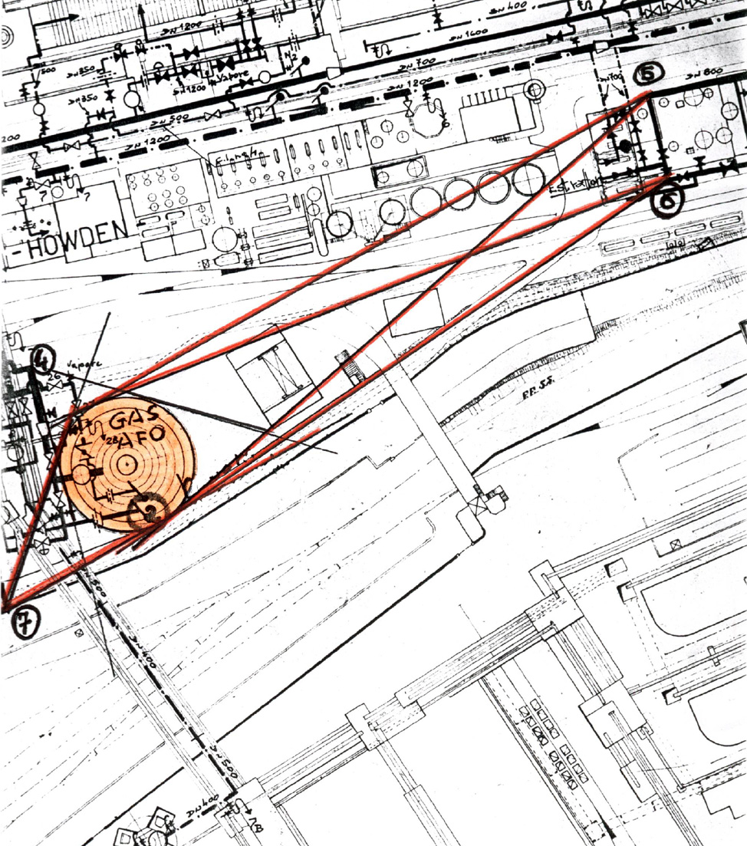

Figure 1. Example of first-kind domino event (LSIE escalation)

4. FREQUENCY ANALYSIS

4.1. Accidental scenarios caused by the first type of domino effects
Figure 1 shows an example of a possible scenario for a first-type domino event. The possibility of confined explosion inside blast-furnace and coke-gas pipe networks was assessed in plant safety report, resulting the possibility of missile projection. An atmospheric blast-furnace gas storage tank was identified as a possible target of missile projection. The primary event is reasonably a LSIE, as confirmed by plant management experience. On the other hand, the secondary event (leak of blast-furnace gas from atmospheric tank puncturing) may result in a major accident.
Frequency of the secondary accident caused by LSIE may be calculated as:
$f_{\text{de}}=f_{p}⋅P_{d}$ (1)
where f_{de} is the expected frequency of the domino event, f_{p} is the expected frequency (events/year) of LSIE and P_{d} is the propagation probability, estimated on the basis of the criteria discussed above:
$P_{d}=P\left(\text{IS}|\text{EILG}\right)$ (2)
If accidental scenarios not previously considered or considered unlikely are identified, the frequency of the secondary accident is equal to f_{de}. If the LSIE is identified as a further cause of the secondary event, the frequency of the secondary event is:
$f_{\text{se}}=f_{\text{pt}}+f_{\text{de}}$ (3)
where f_{se} is the total frequency of secondary top event and f_{pt} is the frequency of top event as a primary event.

Figure 2. Example of second-kind domino event (primary top-event triggering a secondary top-event)

4.2. Accidental scenarios caused by the second type of domino effects
An example of the second type of domino events is given in figure 2. A leak from atmospheric tank 1 may result in a pool fire. Pool fire radiation may cause the failure of a second tank. Both primary event (pool fire in tank 1) and secondary event (tank fire 2) may be regarded as major accidents and are considered in the safety report of the plant.
In the conventional approach for the safety assessment of chemical plants and in QARA studies, it is a common practice to consider the different top events as “independent” and “mutually exclusive” from a probabilistic point of view. This hypothesis (P(1∩2)≈0) may be justified only if primary events expected frequencies have low values and if domino effects of second type may be excluded.
If second-type domino effect events are possible, the “mutual exclusivity” hypothesis should be removed. Thus a quantitative assessment of domino probability may be the following:
$f_{\text{DE}}=f_{p1}⋅P_{d,1→2}+f_{p2}⋅P_{d,2→1}$ (4)
where f_{DE} is the expected frequency of the second type domino event, f_{p1} and f_{p2} the total frequencies of primary events 1 and 2, and P_{d,1→2} and P_{d,2→1} the propagation probabilities. Obviously, in general f_{p1} ≠ f_{p2} and P_{d,1→2} ≠ P_{d,2→1}. In particular, one of the propagation probabilities may be 0 if the physical effects of primary event are not likely to trigger the secondary event.
Furthermore, if second-type domino events are possible, the frequencies of the primary top-events taking place in the absence of domino events should be recalculated:
$f_{\text{pt}1}=f_{p1}⋅\left(1−P_{d,1→2}\right)$ (5)
$f_{\text{pt}2}=f_{p2}⋅\left(1−P_{d,2→1}\right)$ (6)

5. CONSEQUENCE ANALYSIS

5.1. Accidental scenarios caused by the first type of domino effects
With reference to the three different situations defined in section 2.2, consequence assessment of the event is already available in case 3. In cases 1 and 2, conventional methods should be applied, thus requiring the use of quantified event trees, release models and fire, dispersion or explosion models. Vulnerability models based on probit equations may be used to evaluate damage probabilities [4].

5.2. Accidental scenarios caused by the second type of domino effects
Since these scenarios arise from the interaction of two major accidents, a full consequence assessment of the primary and secondary event should be available in the safety reports of the plants.
Thus, a first approach to the consequence analysis may be to neglect the synergetic effects that may arise from accident interaction. Thus accident consequences may be analyzed superimposing the physical effects (radiation, overpressure, toxic gas concentration) separately calculated for the single scenarios that may take place.
A more simple approach is obtained if vulnerability functions are used for damage evaluation. In this case, if the non-linear dependence of dose-effect relation in vulnerability equations may be neglected, damage probabilities of the single events can be directly added to yield at least a rough estimate of the overall damage probability. This result is of particular interest in QARA techniques, were the vulnerability maps of single accidental scenarios are usually available.
Vulnerability is usually estimated in QARA studies using probit functions:
$\text{Pr}=a+b⋅\text{ln}\left(D^{α}⋅t\right)$ (7)
where a, b, and α are parameters depending on the physical effect considered, D is the dose and the time of exposure. A mathematical function correlates damage probability and probit value:
$V=f\left(\text{Pr}\right)$ (8)
where V, the damage probability, ranges between 0 and 1. The vulnerability at a generic position P of the area studied, V_{t}, due to a second-type domino accidental event is given by:
$V_{t}=F\left(V_{1},V_{2}\right)$ (9)
where V₁ and V₂ are the vulnerability values due to top events 1 and 2 respectively, and F is a function that needs to be defined. Since the damage probability ranges between 0 and 1, assuming that consequence maps of the primary and secondary top events are not modified by synergetic effects, the function F may have the following expressions:

1. if the two events cause different types of physical effects (radiation and overpressure, radiation and toxic gas concentration, etc.), and if synergetic effects of the different physical effects are neglected:
$F\left(V_{1},V_{2}\right)=\text{min}\left\{\left(V_{1}+V_{2}\right),1\right\}$ (10)

2. if the two events cause the same physical effect (e.g. radiation) and if it is assumed that synergetic effects may be neglected:
$F\left(V_{1},V_{2}\right)=f\left({\text{Pr}}_{t}\right)$ with ${\text{Pr}}_{t}=\text{Pr}\left({\text{Pr}}_{1}{\text{,Pr}}_{2}\right)$ and ${\text{Pr}}_{i}=f^{−1}\left(V_{i}\right)$, i=1,2 (11)
where f is the function that correlates probit and damage probability (see eq.8). Thus, the total probit value Pr_{t} results from the following:
$\text{Pr}\left({\text{Pr}}_{1}{\text{,Pr}}_{2}\right)=a+b⋅\text{ln}{\left(e^{\frac{{\text{Pr}}_{1}−a}{αb}}+e^{\frac{{\text{Pr}}_{2}−a}{αb}}\right)}^{α}$ (12)
The calculation of (12) may be simplified by a linearization:
$\text{Pr}\left({\text{Pr}}_{1}{\text{,Pr}}_{2}\right)≈β_{1}{\text{Pr}}_{1}+β_{2}{\text{Pr}}_{2}+R_{n}$ (13)

This simplified method was used for a preliminary quantitative assessment of domino effect in a QARA study of an Italian industrial area.

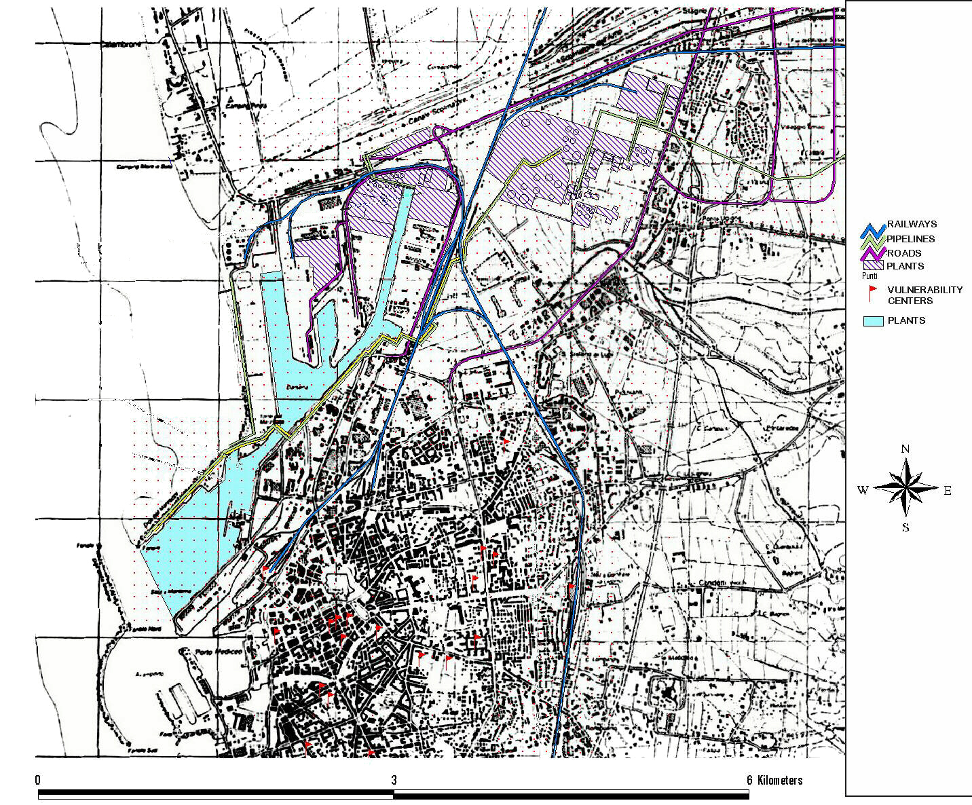

Figure 3. The area considered in the QARA study.

6. ASSESSMENT OF DOMINO HAZARD IN AN INDUSTRIAL AREA

6.1. The QARA study
ARPAT promoted in 1998 a QARA study of an Italian industrial area in the Toscana region. The study was performed by the University of Pisa with the cooperation of two private companies, and was supported also by CNR-GNDRCE. Social and individual risk due to chemical plants and to the transport of hazardous substances to and from the industrial sites and the harbour were evaluated. In order to show the extension of the area considered in the study, a map is reported in fig.3. Table 1 summarizes the accidental scenarios due to fixed installations present in the area.
The QARA study was based on methodologies developed in a previous Italian studies of comprehensive quantitative risk assessment of industrial areas [6]. A GIS-supported software was used for the calculation of social and individual risk. Frequency values and physical effects maps available in safety reports where used to estimate the risk due to fixed installations. Ab-initio analysis of risk related to road, rail, pipe and ship transport of hazardous goods was performed. The results are reported in the literature [16] and will not be further discussed herein.

Table 1
Scenarios due to chemical plants present in the area studied

Type of Scenario | number of events | maximum damage distance (m)
Pool-fire | 106 | 210
UVCE | 78 | 1700
Jet-fire | 53 | 125
Toxic Cloud | 40 | 450
Flash-fire | 26 | 1015
BLEVE | 5 | 220
Fireball | 7 | 3456
Confined Explosion | 7 | 20
Total | 322

Figure 4: Social risk in the area studied considering domino accidental events [16]

6.2. Assessment of domino effect
The above discussed methodology was used to assess the influence of domino events. Only radiation and overpressure effects were considered in the analysis. The approach to propagation probability estimation was based on a worst case hypothesis (P_{d}=1) and on threshold criteria (0.7atm for overpressure and 37.5kW/m² for radiation).
The main source of domino accidents was found to be the LPG storage of an oil refinery present in the area. First type domino accidents were found to have a negligible effect on overall social risk. On the other hand, second-type domino events resulted in a relevant modification of the social risk due to fixed installations, as shown in figure 4. The figure points out that domino events are particularly important for high fatalities (N) values. This indicates that second type of domino effects mainly result in severe accidents.
The worst-case hypothesis used to define propagation probability obviously leads to an overestimation of social risk due to domino hazard. However, the curves reported in figure 4 respectively considering and not considering the domino hazard are the boundaries of the “domino” region. Clearly, the “true” value of social risk should be comprised between the two curves in figure 4. Thus the figure is the starting point to verify the possible use of different propagation probability functions for a more realistic estimate of “domino” hazards.

7. CONCLUSIONS

An approach for a systematic and simplified quantitative assessment of domino effects in QARA was developed. Criteria for the quantitative evaluation of domino scenarios were obtained. The proposed approach shows that only in a limited number of cases a full consequence and frequency assessment is necessary for domino scenarios. In particular, if synergetic effects are neglected, knock on scenarios resulting from the interaction of different "top events" may be evaluated from probabilistic techniques using the maps of the physical effects (radiation, overpressure, toxic concentration) obtained for the single events.
Even if further work is necessary to define reliable propagation probability functions, the results obtained showed that domino hazard highly influences social risk curves, in particular in the high severity (N>100) region.

ACKNOWLEDGEMENTS

The authors gratefully acknowledge Prof. Fausto Gozzi, Dr. Marcello Mossa Verre, Dr. Francesco Marotta, and Dr. Stefano Baldacci for useful discussions, and ARPAT (Agenzia Regionale per la Protezione Ambientale della Toscana) for technical support to the present study. Financial support from CNR - Gruppo Nazionale di Ricerca per la Difesa dai Rischi Chimico-Industriali ed Ecologici is acknowledged.

REFERENCES

[1] C. Delvosalle, Domino effects phenomena: definition, overview and classification, Proc. European seminar on domino effects, Leuven, 1996, p.11.
[2] C. Delvosalle, A methodology for the identification and evaluation of domino effects, Rep. CRC/MT/003, Belgian Ministry of Employment and Labour, Bruxelles, 1998.
[3] F.I. Khan, S.A. Abbasi: “Models for domino effect analysis in chemical process industries”. Proc. Safety Prog. 17 (1998) 107.
[4] F.P. Lees, Loss Prevention in the process industries (II ed.), Butterwoth-Heineman, Oxford (UK), 1996
[5] Council Directive 96/82/EC of 9 December 1996 on the control of major-accident hazards involving dangerous substances. Official Journal of the European Communities, L 10/13 , Brussels, 14.1.97
[6] D.Egidi, F.P.Foraboschi, G.Spadoni, A.Amendola, Reliability Eng. System Safety, 49 (1995) 75
[7] S.Contini, S.Boy, M.Atkinson, N. Labath, M.Banca, J.P.Nordvik, Domino effect evaluation of major industrial installations: a computer aided methodological approach, Proc. European seminar on domino effects, Leuven, 1996, p.1
[8] P.Latha, G.Gautam, K.V.Raghavan, Strategies for tha quantification of thermally initiated cascade effects, J. Loss Prev. Process Ind. 5 (1992) 18
[9] R.L. Greenwood, Research into the methodologies and criteria for domino effects, Proc. European seminar on domino effects, Leuven, 1996, p.19
[10] M.Morris, A. Miles, J. Copper, Quantification of escalation effects in offshore quantitative risk assessment, J. Loss Prev. Process Ind. 7 (1994) 337
[11] G.N.Pettitt, R.R.Schumacher, L.A.Seeley, Evaluating the probability of major hazardous incidents as a result of escalation events, J. Loss Prev. Process Ind. 6 (1993) 37
[12] D.F. Bagster, R.M. Pitblado, The estimation of domino incident frequencies: an approach, Proc.Safety Environ. 69 (1991) 196
[13] R.W.Nelson, Fire protection design, Hydroc. Processing 8 (1977) 103
[14] F.P.Lees, B.R.Poblete, The assessment of major hazards: generalisation of the impact model for the estimation of injury and damage around a hazard source, J. Haz.Mat. 13 (1986) 187
[15] V.Cozzani, W.Folgheraiter, M.Carcassi, Procedures for risk analysis of pipeline networks, Proc. 9th Annual Meeting of the European Society of Risk Analysis, Delft University Press, Delft (NL), 1999, p.134
[16] M. Mossa Verre (Ed.), Analisi del rischio per l’area di Livorno e strategie di intervento, ARPAT, Firenze, 2000

